List of Experiments w.e. f Dec, 2020

|  |  |
| --- | --- |
| Program.No | Description |
| 1 | Create a shopping cart with Angular JS directives, expressions.  Create an application to implement Angular JS controller – likes/dislikes on button hit. |
| 2 | Create a navigation bar in the shopping cart created in program 1- Angular JS  Create a todo list with Angular JS |
| 3 | Create an application to implement Angular JS table  Create an application to implement forms in Angular JS and validation |
| 4 | Create an application to implement dependency injections in Angular JS  Create an application to implement customized services in Angular JS |
|  |  |
| 5 | Create an application to parse student data stored in JSON  Create an application to create html table of student data stored in JSON with Ajax |
| 6 | Create an application to parse XML file with AJAX’s XMLHttpRequest Object.  Create an application to implement get and post in AJAX request. |
| 7 | Create an application to implement Node js exports- Calculator, implement http module |
| 8 | Create an application to implement Node js URL and FS module |
| 9 | Create an application with Node JS and mysql to perform CRUD operations |
| 10 | Create an application with Node JS and mongodb to perform CRUD operations |

**Experiment 1**

PART B

(PART B: TO BE COMPLETED BY STUDENTS)

|  |  |
| --- | --- |
| Roll No.: N049 | Name: Tarun Tanmay |
| Program: MBATech CE | Division: B |
| Batch: B3 | Date of Experiment: |
| Date of Submission: | Grade: |

**B.1 Output   
  
Task1)   
Shopping Cart Web Page:  
(Quantity and Bill)  
  
Code:**

**HTML FILE:**

**Model & Controller:**

<!DOCTYPE html>

<head>

<meta charset="UTF-8">

<meta name="viewport" , content="width=device-width, initia-scale=1.0">

<meta name="description" text="Reseller">

<meta http-equiv="X-UA-Compatible" content="ie-edge">

<meta name="keywords" content="Shopping Cart, Electronics, Laptop, Mobile, Tablet">

<!-- Including Angular Java Script -->

<script src="https://ajax.googleapis.com/ajax/libs/angularjs/1.6.9/angular.min.js"></script>

<!-- Including CSS -->

<link rel="stylesheet" href="shoppingportal.css">

<!-- Linking Font Awesome Scripting -->

<script src="https://kit.fontawesome.com/c21d4d3179.js" crossorigin="anonymous"></script>

<!-- Set Fav Icon-->

<link rel="shortcut icon" type="image/png" href="favicon.png" />

<!-- Title-->

<title> Mac365 | Reseller </title>

</head>

<body id="home">

<!-- Navbar -->

<nav id="navbar">

<h1 class="logo">

<a href="#home"><i class="fa fa-apple" aria-hidden="true"></i> <nbsp> Mac365 | <span class="text-primary">Reseller</span> </a>

</h1>

<ul>

<li><a href="#products">MacBook Pro</a></li>

<li><a href="#mobile">iPhone 12 Pro</a></li>

<li><a href="#tablet">iPad Pro</a></li>

<li><a href="#cart"> Cart</a></li>

</ul>

</nav>

<!-- Angular JS starts-->

<div ng-app="myApp" ng-controller="myCtrl">

<!-- Showcase-->

<header id="showcase">

<div class="showcase-content">

<h1 class="l-heading">

Mac365 | Reseller

</h1>

<!-- Angular JS start -->

<div ng-app="">

<input id="quant" type="text" placeholder="Enter your Name" ng-model="name">

</div>

<h3><br>Hello! <br> {{name}}</h3>

<!-- Angular JS End-->

<h2>

<p class="lead">

Buy Apple Products at cheapest Price in India

</p>

</h2>

<a class="btn" href="#products">Check Our Latest Products</a>

</div>

</header>

<!-- Products-->

<section id="products" class="py-1">

<div class="container">

<h1 class="p-heading text-center">

<br>

<span class="text-primary">Our</span> Products

</h1>

<br>

<div class="items py-1">

<div id="laptop">

<i class="fas fa-laptop fa-2x" aria-hidden="true"></i><img src="MacBook Pro.png" alt="MacBook Pro">

<h3 class="py-4">Macbook Pro 2020 <br> <input id="quant" type="number" placeholder="Quantity" min="0" ng-model="lap_qty"></h3>

</div>

<div class="priced-1">

<h3> Macbook Pro 2020 </h3>

<p> Apple MacBook Pro 13-inch 2020 is a macOS laptop with a 13.30-inch display that has a resolution of 1600x2560 pixels. It is powered by a Core i5 processor and it comes with 8GB of RAM. The Apple MacBook Pro 13-inch 2020 packs 256GB

of SSD storage. Graphics are powered by Intel Integrated Iris Plus Graphics 645. </p>

<p> Priced: Rs 1,10,000

<p>

</div>

</div>

</div>

</section>

<section id="products" class="py-1">

<div class="container">

<div class="items py-1">

<div id="mobile">

<br>

<br>

<br>

<br>

<i class="fa fa-mobile fa-3x" aria-hidden="true"></i><img src="iPhone 12 Pro.png" alt="iPhone 12 Pro">

<h3 class="py-4">iPhone 12 Pro 2020 <br> <input id="quant" type="number" placeholder="Quantity" min="0" ng-model="mob_qty"></h3>

</div>

<br>

<br>

<br>

<br>

<div class="priced-2">

<h3> iPhone 12 Pro 2020 </h3>

<p> iPhone 12 Pro jumps from 8- to 10‑bit HDR recording, capturing 700 million colours for much more lifelike video. Then it goes one better, recording in Dolby Vision — the format used by film studios. You can even edit Dolby Vision

video and use AirPlay to see every last bit of the difference on the big screen. </p>

<p> Priced: Rs 1,00,000 </p>

</div>

</div>

</div>

</section>

<section id="products" class="py-1">

<div class="container">

<div class="items py-1">

<div id="tablet">

<br> <br> <br>

<i class="fa fa-tablet fa-2x" aria-hidden="true"></i><img src="iPad Pro.png" alt="iPad Pro">

<h3 class="py-4">iPad Pro 2020 <br> <input id="quant" type="number" placeholder="Quantity" min='0' ng-model="tab_qty"></h3>

</div>

<div class="priced-3">

<h3> iPad Pro 2020 </h3>

<p> The fourth generation of iPad Pro was announced on March 18, 2020, with the same screen sizes of the previous generation. It offers a redesigned camera module, an A12Z processor, 128 GB minimum storage, and support for the Magic

Keyboard with a trackpad that is sold separately. </p>

<p> Priced: Rs 80,000 </p>

</div>

</div>

</div>

</section>

<!-- Cart -->

<section id="products" class="py-1">

<div class="container" id="cart">

<br><br>

<h1 class="p-heading text-center">

<span class="text-primary">Cart</span> Total

</h1>

<br>

<div class="items py-1">

<img src="cart.png" alt="cart">

<p class="priced-4"> Thankyou for Shopping With Us <br> {{name}} <br> Do Visit us again :) </p>

<div class="priced-1">

<!-- Angular JS stars-->

<br>

<button class="btn priced-1" ng-click="price()">Your Total Billing Amount </button> = <b>Rs {{ +tot_price}}<b>

<!-- Angular JS ends-->

</div>

</div>

</div>

</section>

</div>

<!-- Controller Script -->

<script>

var app = angular.module('myApp',[]);

app.controller('myCtrl', function ($scope){

$scope.price = function() {

$scope.tot_price = (((parseInt($scope.tab_qty || 0) * 80000) + ((parseInt($scope.lap_qty) || 0) * 110000) + ((parseInt($scope.mob_qty) || 0)) * 100000))}});

</script>

<!-- Controller Script ends-->

<!-- Footer-->

<footer id="main-footer" class="bg-dark text-center py-5">

<div class="container">

<p>Copyright &copy; 2020, Mac365 | Reseller ,<br>All Rights Reserved</p>

</div>

</footer>

<!-- Jquery CDN-->

<script

src="https://code.jquery.com/jquery-3.5.0.min.js"

integrity="sha256-xNzN2a4ltkB44Mc/Jz3pT4iU1cmeR0FkXs4pru/JxaQ="

crossorigin="anonymous">

</script>

<!-- Local Javascript File-->

<script src="shoppingportal.js"></script>

</body>

</html>

**CSS File:**

@import url('https://fonts.googleapis.com/css2?family=Roboto:wght@500&display=swap');

* {

box-sizing: border-box;

margin:0;

padding:0;

}

body {

font-family: 'Roboto', sans-serif;

line-height: 1.4;

}

a {

text-decoration: none;

color:white;

}

p {

margin:0.75rem 0;

}

/* Utility Classes*/

.container {

max-width: 1100px;

margin: auto;

padding: 0 2rem;

overflow: hidden;

}

.text-center {

text-align: center;

}

.text-primary {

color: #93cb52;

}

.bg-light {

background: #f4f4f4;

color: #333;

}

.bg-dark {

background: #1b1b1b;

color: #fff;

}

.bg-primary {

background: #93cb52;

color:white;

}

.l-heading {

font-size: 4rem;

margin-bottom: 0.75rem;

line-height: 1.1;

}

.m-heading {

font-size: 2rem;

margin-bottom: 0.75rem;

line-height: 1.1;

}

.p-heading {

font-size: 3rem;

}

.lead {

font-size: 1.3rem;

margin-bottom: 2rem;

font-family: cursive;

}

.py-1{

padding: 1.5rem 0;

color: #1b1b1b;

}

.py-2{

padding: 2rem 0;

}

.py-3{

padding: 3rem 0;

}

.py-4 {

color: white;

}

.py-5 {

padding: 1.5rem 0;

color: white;

}

.priced-1 {

margin-bottom: 0.5rem;

color: white;

text-align: center;

padding: 8rem 0rem 0rem 0rem;

font-family: Anaheim;

font-size: 1.3rem;

font-style: bold;

}

.priced-2{

margin-bottom: 0.5rem;

color: white;

text-align: center;

padding: 18rem 0rem 0rem 0rem;

font-family: Anaheim;

font-size: 1.3rem;

font-style: bold;

}

.priced-3{

margin-bottom: 0.5rem;

color: white;

text-align: center;

padding: 15rem 0rem 0rem 0rem;

font-family: Anaheim;

font-size: 1.3rem;

font-style: bold;

}

.priced-4 {

color: white;

font-family: Anaheim;

text-align: center;

font-size: 1.5rem;

margin-top: 20rem;

margin-left: 2rem;

}

.p-1{

padding: 1.5rem ;

}

.p-2{

padding: 2rem ;

}

.p-3{

padding: 3rem ;

}

.btn, .btn2 {

display: inline-block;

text-align: center;

color: #fff;

background: #93cb52;

padding: 0.5rem 2rem;

border: none;

border-radius: 5px;

}

.btn:hover , .btn2:hover{

background: #b326eb;

color: #000000

}

.btn-dark {

background: #333;

color: #fff;

}

.btn2-dark {

background:#333;

width: 100%;

border-radius: 5px;

}

.btn2 a {

color:#fff;

}

.list {

margin: 0.5rem 0;

list-style: none;

}

.list li {

padding: 0.5rem 0;

border-bottom: #444 dotted 1px;

}

/* Navbar*/

#navbar {

display: flex;

background: #1b1b1b;

position: sticky;

color: #fff;

top:0;

justify-content: space-between;

z-index: 1;

padding: 1rem;

}

#navbar ul {

display: flex;

align-items:center;

list-style: none;

}

#navbar ul li a {

color:#fff;

padding: 0.75rem;

margin: 0 0.25rem;

}

#navbar ul li a:hover {

background: #93cb52;

border-radius: 5px;

}

/* Showcase */

#showcase {

background: #333 url() no-repeat center center/cover;

height: 100vh;

color:#fff;

}

#showcase .showcase-content {

display: flex;

flex-direction: column;

text-align: center;

justify-content: center;

align-items: center;

height: 100%;

padding: 0 2rem;

/* overlay */

position: absolute;

top: 65px;

left: 0;

right:0;

bottom:0;

background-color: rgba(0,0,0,0.4);

}

/* products */

#services .items .item i {

background: #93cb52;

padding: 1rem;

border-radius: 50%;

margin-bottom: 1rem;

}

#products {

color: white;

}

#products .items {

display:flex;

}

#products .items i

{

background: #7250cf;

padding: 1rem;

border-radius: 50%;

margin-top: 0.5rem;

margin-bottom: 1.5rem;

}

#products .items {

text-align: center;

text-decoration: solid;

font-size: 1.5rem;

font-family: cursive;

margin-bottom: 0.5rem;

}

#products .items img{

display:block;

margin: auto;

width:60%;

border-radius: 5px;

margin-bottom: 1.5rem;

}

#products-btn {

text-align: center;

margin-top: .2rem;

}

#products {

background: #333;

}

#products a {

color: white;

}

body #link a {

color: white;

}

body #link a:hover {

color: #93cb42;

}

#quant {

text-align: center;

font-family: Roboto;

font-size: 1.4rem;

}

#cart {

color: white;

height:75vh;

}

**Javascript File:**

// Sticky menu background Transparency

window.addEventListener('scroll', function () {

if (window.scrollY > 150) {

this.document.querySelector('#navbar').style.opacity = 0.9;

} else {

this.document.querySelector('#navbar').style.opacity = 1;

}

}

);

//Smooth Scrolling

$('#navbar a,.btn').on('click', function (event) {

if (this.hash !== '') {

event.preventDefault();

const hash = this.hash;

$('html, body').animate(

{

scrollTop: $(hash).offset().top - 10

},

800

);

}

});

**View:**DataBinding   
Shopping Cart   
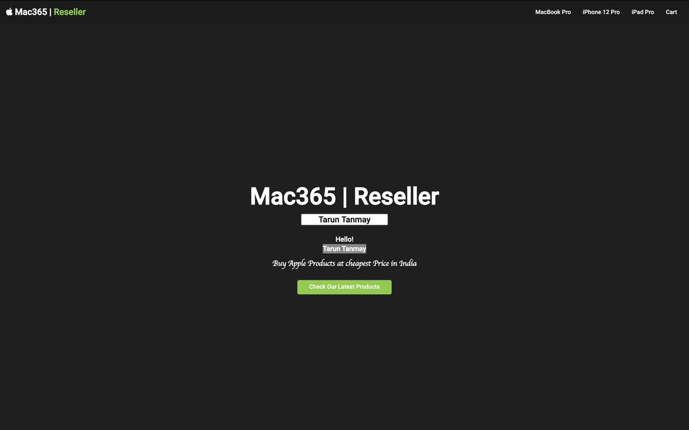

**Two Way Data Binding: {{expression}}**

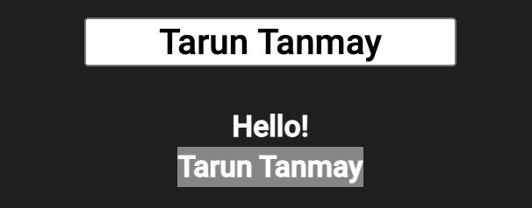

**Shopping Cart Products:**

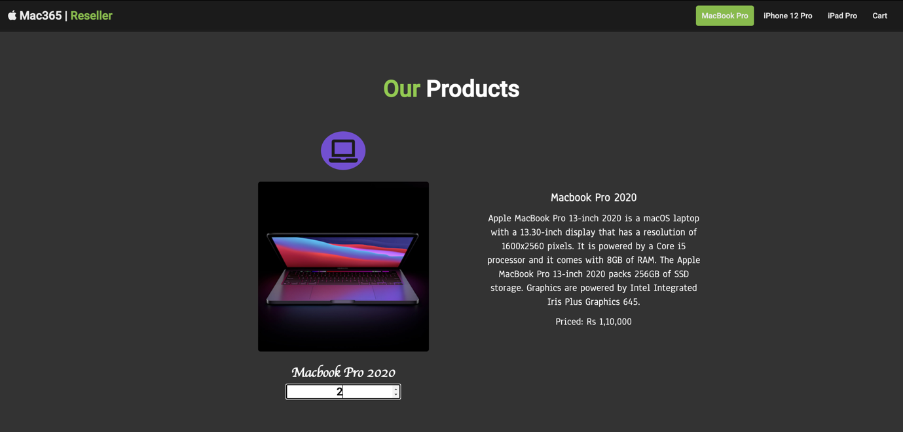

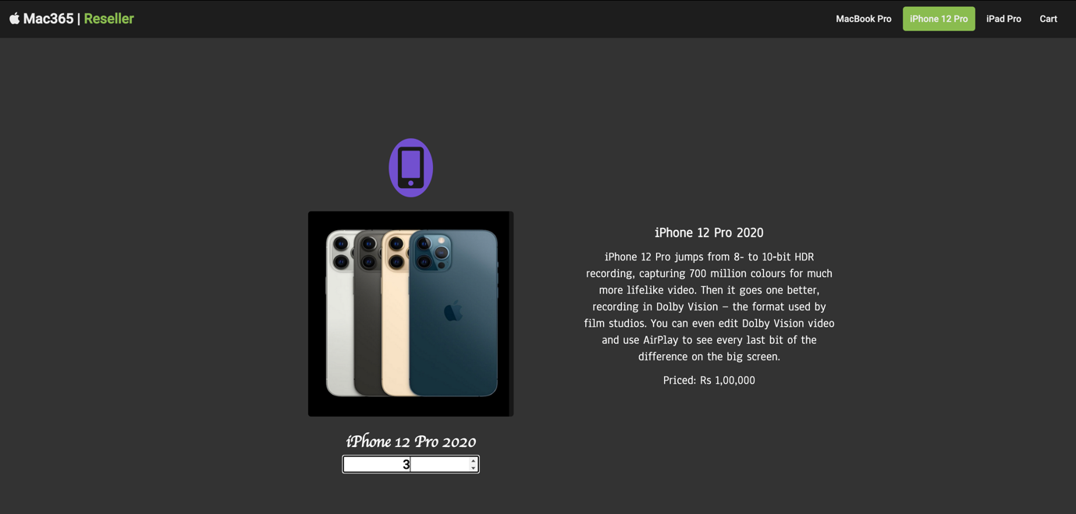

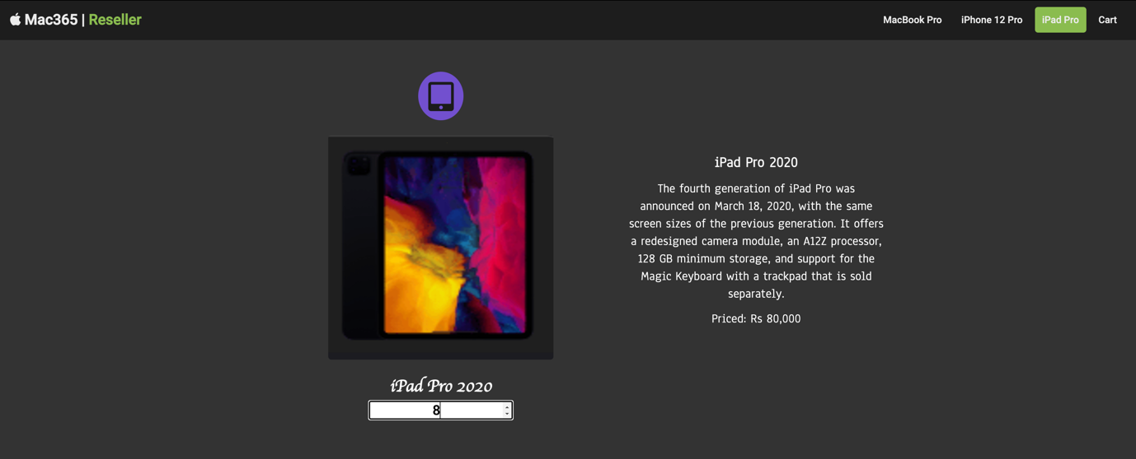

**Shopping Cart Bill:**

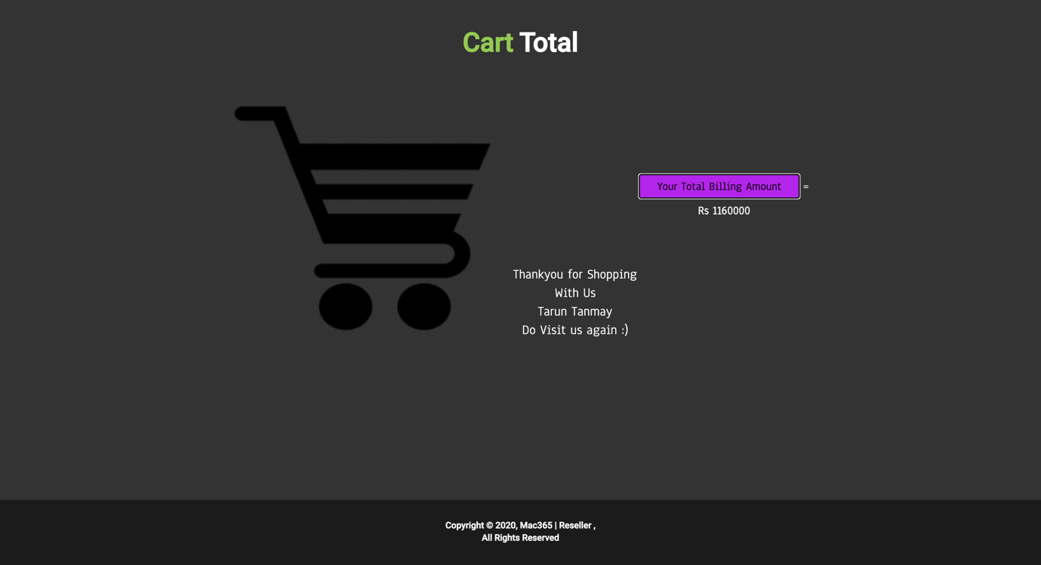

**Task2)   
Footballers Web Page:  
(Like/Dislike Button)  
  
HTML File:  
(Model and Controller)**

<!DOCTYPE html>

<html>

<head>

<meta charset="UTF-8">

<meta name="viewport", content="width=device-width, initial-scale=1.0">

<meta name="description" text="Reseller">

<meta http-equiv="X-UA-Compatible" content="ie-edge">

<meta name="keywords" content="Football, Champions League, Soccer">

<!-- Including Angular Java Script --> <scriptsrc="https://ajax.googleapis.com/ajax/libs/angularjs/1.6.9/angular.min.js"></script>

<!-- Including CSS -->

<link rel="stylesheet" href="task1.css">

<!-- Linking Font Awesome Scripting -->

<script src="https://kit.fontawesome.com/c21d4d3179.js" crossorigin="anonymous"></script>

<!-- Set Fav Icon-->

<link rel="shortcut icon" type="image/png" href="favfoot.jpeg"/>

<!-- Title-->

<title> Madridista 365 </title>

</head>

<body id="home">

<!-- Navbar -->

<nav id="navbar">

<h1 class="logo">

<a href="#home"><i class="fas fa-futbol" aria-hidden="true"></i> <nbsp> Madridista | <span class="text-primary">365</span> </a>

</h1>

<ul>

<li><a href="#products">Cristiano Ronaldo</a></li>

<li><a href="#mobile">Luka Modric</a></li>

<li><a href="#tablet">Luis Figo</a></li>

<li><a href="#cart"> Ricardo Kaka</a></li>

</ul>

</nav>

<!-- Angular JS starts-->

<div ng-app="myApp" ng-controller="myCtrl">

<!-- Showcase-->

<header id="showcase">

<div class="showcase-content">

<h1 class="l-heading">

Madridista | 365

</h1>

<br>

<h2>

<p class="lead">

Welcome to the best football club in the world

</p>

</h2>

<a class="btn" class="ballon" href="#products"> Real Madrid</a>

</div>

</header>

<!-- Products-->

<section id="products" class="py-1">

<div class="container">

<h1 class="p-heading text-center">

<br>

<span class="ballon">Ballon d'Or</span> Winners

</h1>

<br>

<div class="items py-1">

<div id="laptop">

<br>

<img src="Cristiano.jpg" alt="Cristiano Ronaldo">

</div>

<div ng-repeat="player in player1">

<div class="priced-1">

<i class="fa fa-user fa-2x" aria-hidden="true"></i><h3> {{player.name}} </h3>

<p> Cristiano Ronaldo, in full Cristiano Ronaldo dos Santos Aveiro, (born February 5, 1985, Funchal, Madeira, Portugal),

Portuguese football (soccer) forward who was one of the greatest players of his generation.Cristiano Ronaldo is a professional soccer player who has set records while playing for the Manchester United,

Real Madrid and Juventus clubs, as well as the Portuguese national team </p>

<p class="py-4" class="thumb"> Likes = {{player.likes}} </p>

<p class="py-4" class="thumb"> Dislikes= {{player.dislikes}} </p>

<p>

<input class="btn" type="button" value="Like" ng-click="incLike(player)"/>

<nbsp> <input class="btn" type="button" value="Dislike" ng-click="incdisLike(player)"/>

</p>

</div>

</div>

</div>

</div>

</section>

<section id="products" class="py-1">

<div class="container">

<div class="items py-1">

<div id="mobile">

<br>

<br>

<br>

<br>

<img src="luka.jpg" alt="Luka Modric">

</div>

<br>

<br>

<div class="priced-2">

<div ng-repeat="player in player2">

<i class="fa fa-user fa-2x" aria-hidden="true"></i><h3> {{player.name}} </h3>

<p> Luka Modric is a Croatian professional footballer who plays as a midfielder

for Spanish club Real Madrid and captains the Croatia national team. He plays mainly as a central midfielder,

but can also play as an attacking midfielder or as a defensive midfielder, usually deployed as a deep-lying playmaker.

Modric's ability to link play so effectively, and be both shield and supply line, is borne out of his

immaculate technical ability. Modric has retained that vision and ability to pick passes between the

lines as he has moved positionally into a deeper area of the pitch</p>

<p class="py-4" class="thumb"> Likes = {{player.likes}} </p>

<p class="py-4" class="thumb"> Dislikes= {{player.dislikes}} </p>

<p>

<input class="btn" type="button" value="Like" ng-click="incLike(player)"/>

<nbsp> <input class="btn" type="button" value="Dislike" ng-click="incdisLike(player)"/>

</p>

</div>

</div>

</div>

</div>

</section>

<section id="products" class="py-1">

<div class="container">

<div class="items py-1">

<div id="tablet">

<br> <br> <br>

<img src="luis.jpg" alt="Luis Figo">

</div>

<div class="priced-3">

<div ng-repeat="player in player3">

<i class="fa fa-user fa-2x" aria-hidden="true"></i> <h3> {{player.name}}</h3>

<p> Luís Filipe Madeira Caeiro Figo OIH (born 4 November 1972) is a Portuguese retired professional

footballer who played as a midfielder for Sporting CP, Barcelona,

Real Madrid and Inter Milan before retiring on 31 May 2009. Renowned for his

creativity and ability to get past defenders as a winger, Figo is regarded as one

of the greatest players of his generation.

His 106 assists are the second-most in La Liga history. He has also been involved with campaigns to promote better

health and owns a bar in Portugal.</p>

<p class="py-4" class="thumb"> Likes = {{player.likes}} </p>

<p class="py-4" class="thumb"> Dislikes= {{player.dislikes}} </p>

<p>

<input class="btn" type="button" value="Like" ng-click="incLike(player)"/>

<nbsp> <input class="btn" type="button" value="Dislike" ng-click="incdisLike(player)"/>

</p>

</div>

</div>

</div>

</div>

</section>

<section id="products" class="py-1">

<div class="container">

<div class="items py-1">

<div id="cart">

<br> <br> <br>

<img src="kaka.jpeg" alt="Ricardo Kaka">

</div>

<div class="priced-3">

<div ng-repeat="player in player4">

<i class="fa fa-user fa-2x" aria-hidden="true"></i><h3> {{player.name}}</h3>

<p>Kaká, byname of Ricardo Izecson dos Santos Leite, (born April 22, 1982, Brasília,

Brazil), Brazilian football (soccer) player who was named the World Player of the Year by the Fédération

Internationale de Football Association (FIFA) in 2007. Kaká was the first

sportsperson to amass 10 million followers on Twitter.

</p>

<p class="py-4" class="thumb"> Likes = {{player.likes}} </p>

<p class="py-4" class="thumb"> Dislikes= {{player.dislikes}} </p>

<p>

<input class="btn" type="button" value="Like" ng-click="incLike(player)"/>

<nbsp> <input class="btn" type="button" value="Dislike" ng-click="incdisLike(player)"/>

</p>

</div>

</div>

</div>

</div>

</section>

<!-- Cart -->

<!-- <section id="products" class="py-1">

<div class="container" id="cart">

<br><br>

<h1 class="p-heading text-center">

<span class="text-primary">Cart</span>

Total

</h1>

<br>

<div class="items py-1">

</div>

</div>

</section> -->

</div>

<!-- Controller Script -->

<script>

var app = angular.module('myApp',[]);

app.controller('myCtrl', function ($scope)

{

var player1 =

[

{name:'Cristiano Ronaldo',likes:0,dislikes:0},

];

var player2=

[

{name:'Luka Modric',likes:0, dislikes:0},

];

var player3=

[

{name:'Luis Figo',likes:0, dislikes:0},

];

var player4=

[

{name:'Ricardo Kaka',likes:0, dislikes:0},

];

$scope.player1=player1;

$scope.player2=player2;

$scope.player3=player3;

$scope.player4=player4;

$scope.incLike=function(player)

{

player.likes++;

}

$scope.incdisLike=function(player)

{

player.dislikes++;

}

});

</script>

<!-- Controller Script ends-->

<!-- Footer-->

<footer id="main-footer" class="bg-dark text-center py-5">

<div class="container">

<p class="footer">Copyright &copy; 2020, Madridista | 365,<br>All Rights Reserved</p>

</div>

</footer>

<!-- Jquery CDN-->

<script src="https://code.jquery.com/jquery-3.5.0.min.js"

integrity="sha256-xNzN2a4ltkB44Mc/Jz3pT4iU1cmeR0FkXs4pru/JxaQ=" crossorigin="anonymous">

</script>

<script src="task1.js">

</script>

</body>

</html>

**CSS File:**

@import url('https://fonts.googleapis.com/css2?family=Roboto:wght@500&display=swap');

* {

box-sizing: border-box;

margin:0;

padding:0;

}

body {

font-family: 'Roboto', sans-serif;

line-height: 1.4;

}

a {

text-decoration: none;

color:white;

}

p {

margin:0.75rem 0;

}

/* Utility Classes*/

.container {

max-width: 1100px;

margin: auto;

padding: 0 2rem;

overflow: hidden;

}

.text-center {

text-align: center;

}

.text-primary {

color: #93cb52;

}

.bg-light {

background: #f4f4f4;

color: #333;

}

.bg-dark {

background: #1b1b1b;

color: #fff;

}

.bg-primary {

background: #93cb52;

color:white;

}

.l-heading {

font-size: 4rem;

margin-bottom: 0.75rem;

line-height: 1.1;

padding: 7rem 0 0 0;

}

.m-heading {

font-size: 2rem;

margin-bottom: 0.75rem;

line-height: 1.1;

}

.p-heading {

font-size: 3rem;

}

.lead {

font-size: 1.5rem;

margin-bottom: 2rem;

letter-spacing: 0.5rem;

font-family: cursive;

text-align: center;

padding: 0 0.5rem 2.5rem 0.5rem;

}

.py-1{

padding: 1.5rem 0;

color: #1b1b1b;

}

.py-2{

padding: 2rem 0;

}

.py-3{

padding: 3rem 0;

}

.py-4 {

color: white;

}

.py-5 {

padding: 1.5rem 0;

color: white;

}

.priced-1 {

margin-bottom: 0rem;

color: white;

text-align: center;

padding: 0.5rem 0rem 0rem 0rem;

font-family: Anaheim;

font-size: 1.3rem;

font-style: bold;

}

.priced-2{

margin-top: 0rem;

color: white;

text-align: center;

padding: 7rem 0rem 0rem 0rem;

font-family: Anaheim;

font-size: 1.3rem;

font-style: bold;

}

.priced-3{

margin-bottom: 0rem;

color: white;

text-align: center;

padding: 7rem 0rem 0rem 0rem;

font-family: Anaheim;

font-size: 1.3rem;

font-style: bold;

}

.priced-4 {

color: white;

font-family: Anaheim;

text-align: center;

font-size: 1.5rem;

margin-top: 20rem;

margin-left: 2rem;

}

.p-1{

padding: 1.5rem ;

}

.p-2{

padding: 2rem ;

}

.p-3{

padding: 3rem ;

}

.btn, .btn2 {

line-height: 1.5rem;

text-align: center;

font-size: 1.5rem;

display: inline-block;

text-align: center;

color: #fff;

background: #93cb52;

padding: 0.5rem 3rem;

border: none;

border-radius: 5px;

}

.btn:hover , .btn2:hover{

background: #b326eb;

color: #000000;

}

.btn-dark {

background: #333;

color: #fff;

}

.btn2-dark {

background:#333;

width: 100%;

border-radius: 5px;

}

.btn2 a {

color:#fff;

}

.list {

margin: 0.5rem 0;

list-style: none;

}

.list li {

padding: 0.5rem 0;

border-bottom: #444 dotted 1px;

}

/* Navbar*/

#navbar {

display: flex;

background: #1b1b1b;

position: sticky;

color: #fff;

top:0;

justify-content: space-between;

z-index: 1;

padding: 1rem;

}

#navbar ul {

display: flex;

align-items:center;

list-style: none;

}

#navbar ul li a {

color:#fff;

padding: 0.75rem;

margin: 0 0.25rem;

}

#navbar ul li a:hover {

background: #93cb52;

border-radius: 5px;

}

/* Showcase */

#showcase {

background: #333 url('real.png') no-repeat center center/cover;

height: 100vh;

color:#fff;

}

#showcase .showcase-content {

display: flex;

flex-direction: column;

text-align: center;

justify-content: center;

align-items: center;

height: 100%;

padding: 0 2rem;

/* overlay */

position: absolute;

top: 65px;

left: 0;

right:0;

bottom:0;

background-color: rgba(0,0,0,0.7);

}

/* products */

#services .items .item i {

background: #93cb52;

padding: 1rem;

border-radius: 50%;

margin-bottom: 1rem;

}

#products {

color: white;

}

#products .items {

display:flex;

}

#products .items i

{

background: #7250cf;

padding: 1rem;

border-radius: 50%;

margin-top: 0.5rem;

margin-bottom: 1.5rem;

color: black;

}

#products .items {

text-align: center;

text-decoration: solid;

font-size: 1.5rem;

font-family: cursive;

margin-bottom: 0.5rem;

}

#products .items img{

display:block;

margin: auto;

width:60%;

border-radius: 5px;

margin-bottom: 1.5rem;

}

#products-btn {

text-align: center;

margin-top: .2rem;

}

#products {

background: #333;

}

#products a {

color: white;

}

body #link a {

color: white;

}

body #link a:hover {

color: #93cb42;

}

#quant {

text-align: center;

font-family: Roboto;

font-size: 1.4rem;

}

#cart {

height:20vh;

}

#tablet {

height: 20vh;

}

#tablet img {

padding: 9rem 0 0 0;

}

.thumb {

margin-left: 30vh;

}

#mobile img {

padding: 7rem 0 0 0;

}

#cart img {

padding: 5rem 0 0 0;

}

.footer {

font-size: 1.2rem;

margin-bottom: 1rem;

}

#laptop img {

padding: 4rem 0 0 0;

}

.ballon {

color: #ffd700;

}

**Javascript File:**

// Sticky menu background Transparency

window.addEventListener('scroll', function () {

if (window.scrollY > 150) {

this.document.querySelector('#navbar').style.opacity = 0.9;

} else {

this.document.querySelector('#navbar').style.opacity = 1;

}

}

);

//Smooth Scrolling

$('#navbar a,.btn').on('click', function (event) {

if (this.hash !== '') {

event.preventDefault();

const hash = this.hash;

$('html, body').animate(

{

scrollTop: $(hash).offset().top - 1

},

800

);

}

});

**View:  
  
**

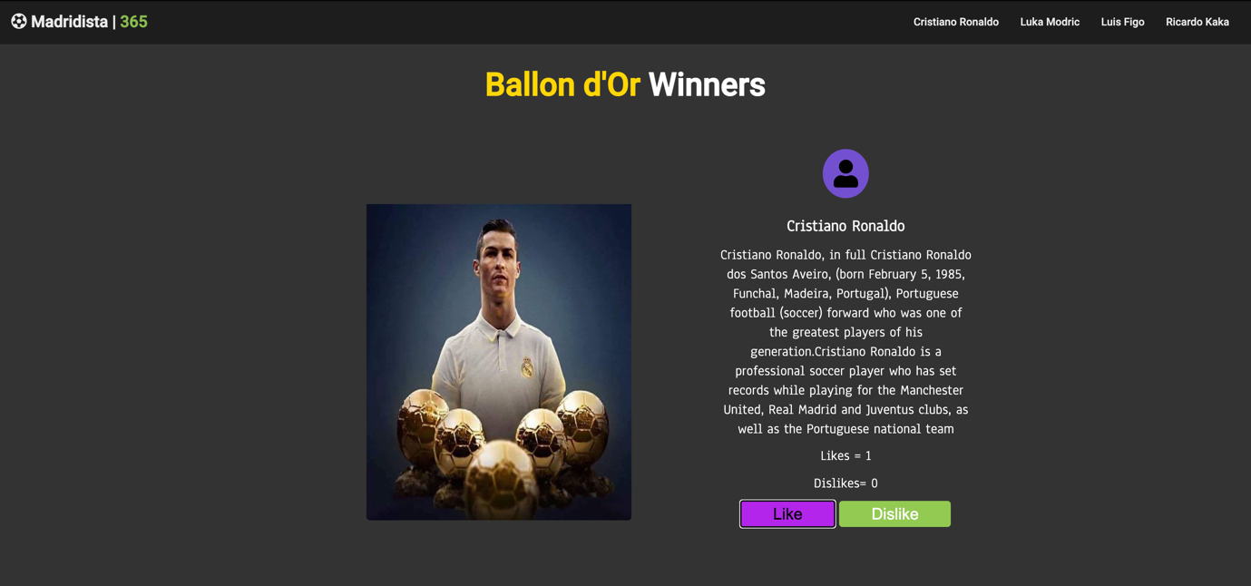

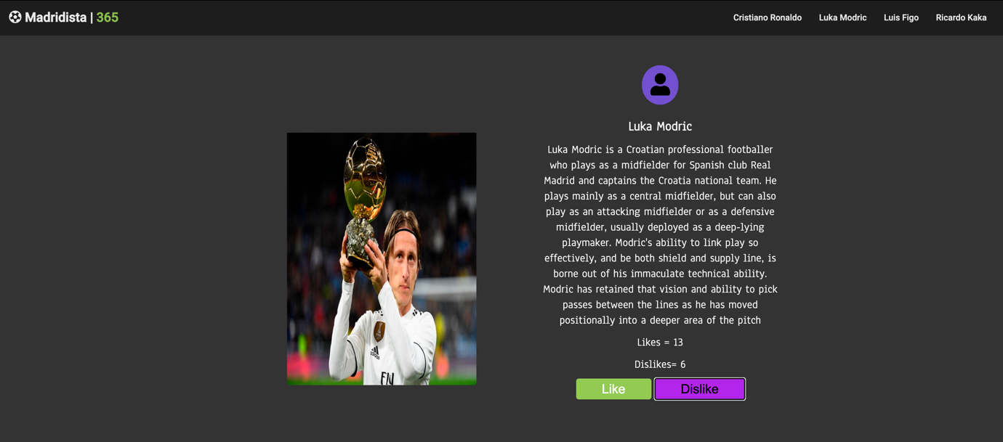

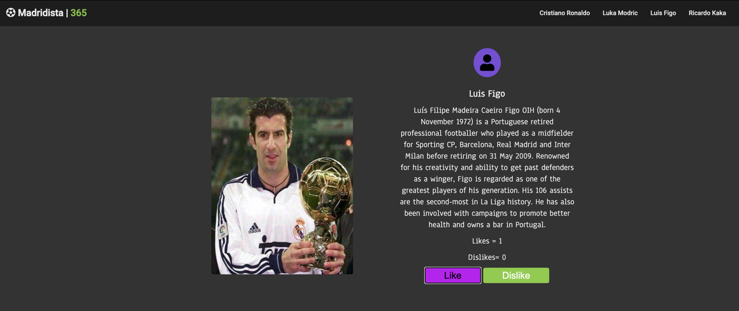

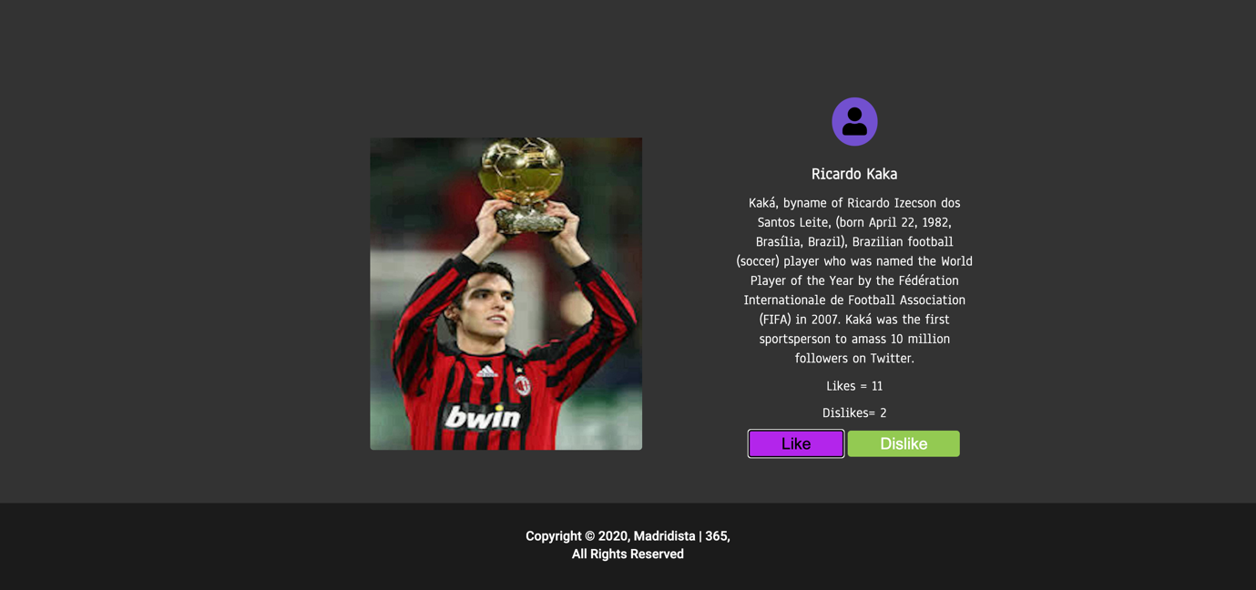

**B.2 Observations/Learning:**  
  
In the above two tasks, I’ve implemented an Angular JS application which includes a shopping cart billing system and like and dislike on-hit buttons.   
Expressions are used to bind the data in html in the ng-app which is fed by the controller. The controller also being responsible for handling user generated functions for calculating shopping cart bill according to quantity of the product and updating the likes and dislikes in the application and reflecting it in the view.

**B.3 Conclusion:**   
  
Through this experiment, I’ve learned about the basics of AngularJS, the functioning of its directives, expressions, controller and two-way data binding between model and view.

**Experiment 2**

PART B

(PART B: TO BE COMPLETED BY STUDENTS)

**(Students must submit the soft copy as per following segments within two hours of the practical. The soft copy must be uploaded on the Blackboard or emailed to the concerned lab in charge faculties at the end of the practical in case the there is no Black board access available)**

|  |  |
| --- | --- |
| Roll No.: N049 | Name: Tarun Tanmay |
| Program: MBATech CE | Division: B |
| Batch: B3 | Date of Experiment: |
| Date of Submission: | Grade: |

**B.1 Output:**

**Task1)  
Navigation Bar in Shopping Cart:**

**Model & Controller:**

<!DOCTYPE html>

<head>

<meta charset="UTF-8">

<meta name="viewport" , content="width=device-width, initia-scale=1.0">

<meta name="description" text="Reseller">

<meta http-equiv="X-UA-Compatible" content="ie-edge">

<meta name="keywords" content="Shopping Cart, Electronics, Laptop, Mobile, Tablet">

<!-- Including Angular Java Script -->

<script src="https://ajax.googleapis.com/ajax/libs/angularjs/1.6.9/angular.min.js"></script>

<!-- Including CSS -->

<link rel="stylesheet" href="shoppingportal.css">

<!-- Linking Font Awesome Scripting -->

<script src="https://kit.fontawesome.com/c21d4d3179.js" crossorigin="anonymous"></script>

<!-- Set Fav Icon-->

<link rel="shortcut icon" type="image/png" href="favicon.png" />

<!-- Title-->

<title> Mac365 | Reseller </title>

</head>

<body id="home">

<!-- Navbar -->

<div ng-app="Navigation" ng-controller="Controller">

<nav id="navbar">

<h1 class="logo">

<a href="#home"><i class="fa fa-apple" aria-hidden="true"></i>

<nbsp> Mac365 | <span class="text-primary">Reseller</span>

</a>

</h1>

<a href="#" ng-repeat="n in nav" ng-click="Navigation(n)">{{n}}</a>

<p>You chose <b>{{options}}</b></p>

</nav>

</div>

<!-- Angular JS starts-->

<div ng-app="myApp" ng-controller="myCtrl">

<!-- Showcase-->

<header id="showcase">

<div class="showcase-content">

<h1 class="l-heading">

Mac365 | Reseller

</h1>

<!-- Angular JS start -->

<div ng-app="">

<input id="quant" type="text" placeholder="Enter your Name" ng-model="name">

</div>

<h3><br>Hello! <br> {{name}}</h3>

<!-- Angular JS End-->

<h2>

<p class="lead">

Buy Apple Products at cheapest Price in India

</p>

</h2>

<a class="btn" href="#products">Check Our Latest Products</a>

</div>

</header>

<!-- Products-->

<section id="products" class="py-1">

<div class="container">

<h1 class="p-heading text-center">

<br>

<span class="text-primary">Our</span> Products

</h1>

<br>

<div class="items py-1">

<div id="laptop">

<i class="fas fa-laptop fa-2x" aria-hidden="true"></i><img src="MacBook Pro.png"

alt="MacBook Pro">

<h3 class="py-4">Macbook Pro 2020 <br> <input id="quant" type="number" placeholder="Quantity"

min="0" ng-model="lap_qty"></h3>

</div>

<div class="priced-1">

<h3> Macbook Pro 2020 </h3>

<p> Apple MacBook Pro 13-inch 2020 is a macOS laptop with a 13.30-inch display that has a

resolution of 1600x2560 pixels. It is powered by a Core i5 processor and it comes with 8GB

of RAM. The Apple MacBook Pro 13-inch 2020 packs 256GB

of SSD storage. Graphics are powered by Intel Integrated Iris Plus Graphics 645. </p>

<p> Priced: Rs 1,10,000

<p>

</div>

</div>

</div>

</section>

<section id="products" class="py-1">

<div class="container">

<div class="items py-1">

<div id="mobile">

<br>

<br>

<br>

<br>

<i class="fa fa-mobile fa-3x" aria-hidden="true"></i><img src="iPhone 12 Pro.png"

alt="iPhone 12 Pro">

<h3 class="py-4">iPhone 12 Pro 2020 <br> <input id="quant" type="number" placeholder="Quantity"

min="0" ng-model="mob_qty"></h3>

</div>

<br>

<br>

<br>

<br>

<div class="priced-2">

<h3> iPhone 12 Pro 2020 </h3>

<p> iPhone 12 Pro jumps from 8- to 10‑bit HDR recording, capturing 700 million colours for much

more lifelike video. Then it goes one better, recording in Dolby Vision — the format used by

film studios. You can even edit Dolby Vision

video and use AirPlay to see every last bit of the difference on the big screen. </p>

<p> Priced: Rs 1,00,000 </p>

</div>

</div>

</div>

</section>

<section id="products" class="py-1">

<div class="container">

<div class="items py-1">

<div id="tablet">

<br> <br> <br>

<i class="fa fa-tablet fa-2x" aria-hidden="true"></i><img src="iPad Pro.png" alt="iPad Pro">

<h3 class="py-4">iPad Pro 2020 <br> <input id="quant" type="number" placeholder="Quantity"

min='0' ng-model="tab_qty"></h3>

</div>

<div class="priced-3">

<h3> iPad Pro 2020 </h3>

<p> The fourth generation of iPad Pro was announced on March 18, 2020, with the same screen

sizes of the previous generation. It offers a redesigned camera module, an A12Z processor,

128 GB minimum storage, and support for the Magic

Keyboard with a trackpad that is sold separately. </p>

<p> Priced: Rs 80,000 </p>

</div>

</div>

</div>

</section>

<!-- Cart -->

<section id="products" class="py-1">

<div class="container" id="cart">

<br><br>

<h1 class="p-heading text-center">

<span class="text-primary">Cart</span> Total

</h1>

<br>

<div class="items py-1">

<img src="cart.png" alt="cart">

<p class="priced-4"> Thankyou for Shopping With Us <br> {{name}} <br> Do Visit us again :) </p>

<div class="priced-1">

<!-- Angular JS stars-->

<br>

<button class="btn priced-1" ng-click="price()">Your Total Billing Amount </button> = <b>Rs {{

+tot_price}}<b>

<!-- Angular JS ends-->

</div>

</div>

</div>

</section>

</div>

<!-- Controller Script -->

<script>

//NavBar Controller

var app = angular.module("Navigation", []);

app.controller('Controller', ['$scope', function ($scope) {

$scope.nav = ['Macbook Pro 12', 'iPhone 12 Pro', 'iPad Pro', 'Cart'];

$scope.Navigation = function (options) {

$scope.options = options;

console.log($scope.options);

}

}

]);

</script>

<script>

//Shopping Cart Controller

var app = angular.module('myApp', []);

app.controller('myCtrl', function ($scope) {

$scope.price = function () {

$scope.tot_price = (((parseInt($scope.tab_qty || 0) * 80000) + ((parseInt($scope.lap_qty) || 0) * 110000) + ((parseInt($scope.mob_qty) || 0)) * 100000))

}

});

</script>

<!-- Controller Script ends-->

<!-- Footer-->

<footer id="main-footer" class="bg-dark text-center py-5">

<div class="container">

<p>Copyright &copy; 2020, Mac365 | Reseller ,<br>All Rights Reserved</p>

</div>

</footer>

<!-- Jquery CDN-->

<script src="https://code.jquery.com/jquery-3.5.0.min.js"

integrity="sha256-xNzN2a4ltkB44Mc/Jz3pT4iU1cmeR0FkXs4pru/JxaQ=" crossorigin="anonymous">

</script>

<!-- Local Javascript File-->

<script src="shoppingportal.js"></script>

</div>

</body>

</html>

**CSS File:**

@import url('https://fonts.googleapis.com/css2?family=Roboto:wght@500&display=swap');

* {

box-sizing: border-box;

margin:0;

padding:0;

}

body {

font-family: 'Roboto', sans-serif;

line-height: 1.4;

}

a {

text-decoration: none;

color:white;

}

p {

margin:0.75rem 0;

}

/* Utility Classes*/

.container {

max-width: 1100px;

margin: auto;

padding: 0 2rem;

overflow: hidden;

}

.text-center {

text-align: center;

}

.text-primary {

color: #93cb52;

}

.bg-light {

background: #f4f4f4;

color: #333;

}

.bg-dark {

background: #1b1b1b;

color: #fff;

}

.bg-primary {

background: #93cb52;

color:white;

}

.l-heading {

font-size: 4rem;

margin-bottom: 0.75rem;

line-height: 1.1;

padding: 7rem 0 0 0;

}

.m-heading {

font-size: 2rem;

margin-bottom: 0.75rem;

line-height: 1.1;

}

.p-heading {

font-size: 3rem;

}

.lead {

font-size: 1.5rem;

margin-bottom: 2rem;

letter-spacing: 0.5rem;

font-family: cursive;

text-align: center;

padding: 0 0.5rem 2.5rem 0.5rem;

}

.py-1{

padding: 1.5rem 0;

color: #1b1b1b;

}

.py-2{

padding: 2rem 0;

}

.py-3{

padding: 3rem 0;

}

.py-4 {

color: white;

}

.py-5 {

padding: 1.5rem 0;

color: white;

}

.priced-1 {

margin-bottom: 0rem;

color: white;

text-align: center;

padding: 0.5rem 0rem 0rem 0rem;

font-family: Anaheim;

font-size: 1.3rem;

font-style: bold;

}

.priced-2{

margin-top: 0rem;

color: white;

text-align: center;

padding: 7rem 0rem 0rem 0rem;

font-family: Anaheim;

font-size: 1.3rem;

font-style: bold;

}

.priced-3{

margin-bottom: 0rem;

color: white;

text-align: center;

padding: 7rem 0rem 0rem 0rem;

font-family: Anaheim;

font-size: 1.3rem;

font-style: bold;

}

.priced-4 {

color: white;

font-family: Anaheim;

text-align: center;

font-size: 1.5rem;

margin-top: 20rem;

margin-left: 2rem;

}

.p-1{

padding: 1.5rem ;

}

.p-2{

padding: 2rem ;

}

.p-3{

padding: 3rem ;

}

.btn, .btn2 {

line-height: 1.5rem;

text-align: center;

font-size: 1.5rem;

display: inline-block;

text-align: center;

color: #fff;

background: #93cb52;

padding: 0.5rem 3rem;

border: none;

border-radius: 5px;

}

.btn:hover , .btn2:hover{

background: #b326eb;

color: #000000;

}

.btn-dark {

background: #333;

color: #fff;

}

.btn2-dark {

background:#333;

width: 100%;

border-radius: 5px;

}

.btn2 a {

color:#fff;

}

.list {

margin: 0.5rem 0;

list-style: none;

}

.list li {

padding: 0.5rem 0;

border-bottom: #444 dotted 1px;

}

/* Navbar*/

#navbar {

display: flex;

background: #1b1b1b;

position: sticky;

color: #fff;

top:0;

justify-content: space-between;

z-index: 1;

padding: 1rem;

}

#navbar ul {

display: flex;

align-items:center;

list-style: none;

}

#navbar ul li a {

color:#fff;

padding: 0.75rem;

margin: 0 0.25rem;

}

#navbar ul li a:hover {

background: #93cb52;

border-radius: 5px;

}

/* Showcase */

#showcase {

background: #333 url('real.png') no-repeat center center/cover;

height: 100vh;

color:#fff;

}

#showcase .showcase-content {

display: flex;

flex-direction: column;

text-align: center;

justify-content: center;

align-items: center;

height: 100%;

padding: 0 2rem;

/* overlay */

position: absolute;

top: 65px;

left: 0;

right:0;

bottom:0;

background-color: rgba(0,0,0,0.7);

}

/* products */

#services .items .item i {

background: #93cb52;

padding: 1rem;

border-radius: 50%;

margin-bottom: 1rem;

}

#products {

color: white;

}

#products .items {

display:flex;

}

#products .items i

{

background: #7250cf;

padding: 1rem;

border-radius: 50%;

margin-top: 0.5rem;

margin-bottom: 1.5rem;

color: black;

}

#products .items {

text-align: center;

text-decoration: solid;

font-size: 1.5rem;

font-family: cursive;

margin-bottom: 0.5rem;

}

#products .items img{

display:block;

margin: auto;

width:60%;

border-radius: 5px;

margin-bottom: 1.5rem;

}

#products-btn {

text-align: center;

margin-top: .2rem;

}

#products {

background: #333;

}

#products a {

color: white;

}

body #link a {

color: white;

}

body #link a:hover {

color: #93cb42;

}

#quant {

text-align: center;

font-family: Roboto;

font-size: 1.4rem;

}

#cart {

height:20vh;

}

#tablet {

height: 20vh;

}

#tablet img {

padding: 9rem 0 0 0;

}

.thumb {

margin-left: 30vh;

}

#mobile img {

padding: 7rem 0 0 0;

}

#cart img {

padding: 5rem 0 0 0;

}

.footer {

font-size: 1.2rem;

margin-bottom: 1rem;

}

#laptop img {

padding: 4rem 0 0 0;

}

.ballon {

color: #ffd700;

}

**Javascript File:**

// Sticky menu background Transparency

window.addEventListener('scroll', function () {

if (window.scrollY > 150) {

this.document.querySelector('#navbar').style.opacity = 0.9;

} else {

this.document.querySelector('#navbar').style.opacity = 1;

}

}

);

//Smooth Scrolling

$('#navbar a,.btn').on('click', function (event) {

if (this.hash !== '') {

event.preventDefault();

const hash = this.hash;

$('html, body').animate(

{

scrollTop: $(hash).offset().top - 1

},

800

);

}

});

**View:**

**Navigation Bar:**



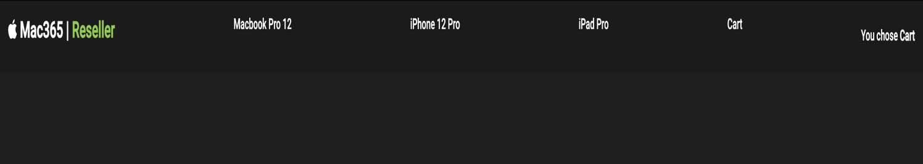

**Task2)**

**To-do List with Angular JS:  
  
Model & Controller:**

<!DOCTYPE html>

<html>

<head>

<title> Reminders </title>

<!-- Including Angular JS -->

<script src="https://ajax.googleapis.com/ajax/libs/angularjs/1.6.9/angular.min.js"></script>

<link rel="stylesheet" href="Exp2.css">

</head>

<body>

<div ng-app="myapp" ng-controller="remindercont">

<!-- Creating Reminder Form-->

<h1> To-Do List</h1>

<form name="reminderform" ng-submit="additem()">

<input class="text" type="text" name="reminder" ng-model="reminder" required />

<br>

<br>

<button class="btn" ng-disabled="reminderform.$invalid">Set Reminder</button>

<br>

<br>

<button class="btn" ng-click="clearitem()"> Clear Reminder </button>

</form>

<ul class="list">

<ul ng-repeat="i in items" />

<input type="checkbox" ng-model="i.done">

<span> {{i.title}}</span>

</ul>

</ul>

</div>

<!-- Controller Program-->

<script>

var app = angular.module("myapp", []);

app.controller('remindercont', function ($scope) {

$scope.items = [{ 'title': 'Add New Reminder', 'done': false }];

$scope.additem = function () {

$scope.items.push({ 'title': $scope.reminder, 'done': false });

$scope.reminder = '';

}

$scope.clearitem = function () {

$scope.items = $scope.items.filter(function (i) {

return !i.done;

})

}

});

</script>

</body>

</html>

**CSS File:**

body {

color: white;

text-align: center;

margin-top: 15vh;

background: rgba(0, 0, 0, 0.95);

}

.text {

height: 2rem;

padding: 0 1rem;

line-height: 2.5rem;

}

.btn {

height: 2rem;

padding: 0 4rem;

line-height: 1.5rem;

}

.list {

line-height: 1.5rem;

padding: 2px;

}

**View:**

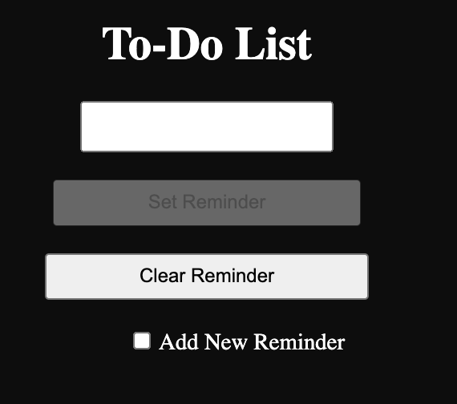 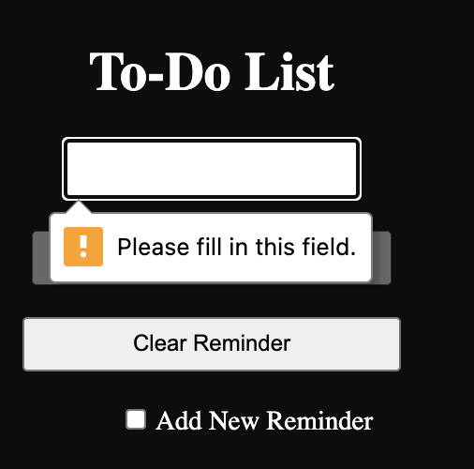

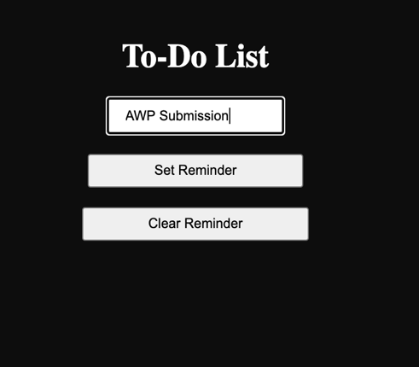 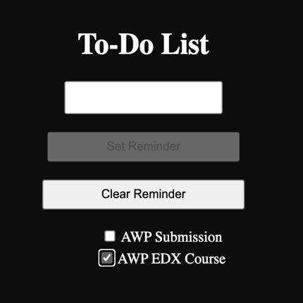 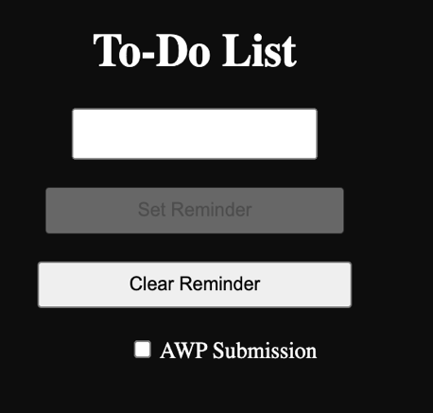

**B.2 Observations/Learning:**  
In the above two experiments, I’ve successfully implemented Angular Js applications for a navigation bar and to-do list. Where, I’ve learnt to implement the ng-repeat, ng-click, ng-disabled directives and expressions in angular js with writing proper business logic (controller script).

**B.3 Conclusion:**Through this experiment, I’ve learned about the basics of built-in directives of the Angular JS framework, their functioning and implementation of expressions for two-way data binding.

**Experiment 3**

PART B

(PART B: TO BE COMPLETED BY STUDENTS)

**(Students must submit the soft copy as per following segments within two hours of the practical. The soft copy must be uploaded on the Blackboard or emailed to the concerned lab in charge faculties at the end of the practical in case the there is no Black board access available)**

|  |  |
| --- | --- |
| Roll No.: N049 | Name: Tarun Tanmay |
| Program: MBATech CE | Division: B |
| Batch: B3 | Date of Experiment: |
| Date of Submission: | Grade: |

**B.1 Output:**

**Task1)  
  
Angular JS Table:**

**Model & Controller:**

<!DOCTYPE html>

<html>

<head>

<meta charset="UTF-8" />

<meta name="viewport" , content="width=device-width, initial-scale=1.0" />

<meta name="description" text="Timetable" />

<meta http-equiv="X-UA_Compatible" content="ie-edge" />

<meta name=" keywords " content="Timetable, Semester, Marks " />

<link rel="icon" type="image/png" sizes="32x32" href="/favicon-32x32.png">

<title>Semester Marks Table</title>

<!-- Link Angular JS-->

<script src="https://ajax.googleapis.com/ajax/libs/angularjs/1.6.9/angular.min.js"></script>

</head>

<body>

<style>

table,

th,

td {

border: 1px solid grey;

padding: 5px;

}

</style>

<h1>Semester Marks Report</h1>

<div ng-app="myApp" ng-controller="myCtrl">

<table>

<th> Sr. No</th>

<th> Name </th>

<th> Subject </th>

<th> Marks </th>

<tr ng-repeat="s in details | orderBy: 'Name' ">

<td> {{$index+1}}</td>

<td> {{s.Name | uppercase}}</td>

<td> {{s.Subject}}</td>

<td> {{s.marks}}</td>

</tr>

</table>

</div>

<!-- Controller Script-->

<script>

var app=angular.module('myApp',[]);

app.controller('myCtrl',function($scope)

{

$scope.details=

[

{Name:"Eminem", Subject:"Advanced Web Programming", marks:100},

{Name:"Slim Shady", Subject:"Artificial Intelligence", marks:100},

{Name:"White Rabbit", Subject:"Unix Programming", marks:100},

{Name:"Marshall Mathers", Subject:"Software Engineering", marks:100},

]

}

);

</script>

</body>

</html>

**View:**

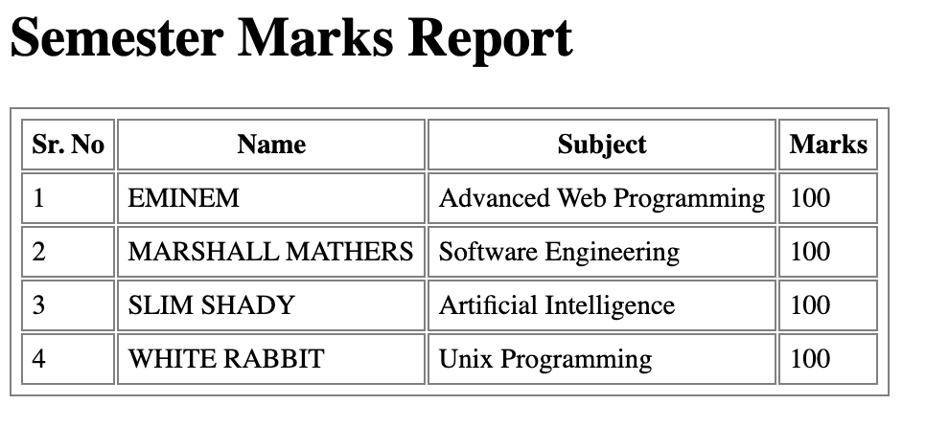

**Task2)**

**Form Validation in Angular JS:  
  
Model & Controller:**

<!DOCTYPE html>

<html>

<head>

<meta charset="UTF-8">

<meta name="description" text="validation form">

<meta name="viewport" , content="width=device-width, initial-scale=1.0">

<meta name="keywords" content="form, validation, angularJS">

<meta http-equiv="X-UA-Compatible" content="ie-edge">

<title>

Form Validation

</title>

<!-- Link CSS-->

<link rel="stylesheet" href="Exp3_2.css">

<!-- Link Angular -->

<script src="https://ajax.googleapis.com/ajax/libs/angularjs/1.6.9/angular.min.js"></script>

<style>

input.ng-pristine {

background-color: yellow;

}

input.ng-touched.ng-invalid {

background-color: red;

}

input.ng-touched.ng-valid {

background-color: green;

}

</style>

</head>

<body>

<h2> Form Validation</h2>

<div ng-app="myApp" ng-controller="myCtrl">

<form class="form" name="form" novalidate>

<!-- First Name-->

<label for="FirstName">First Name</label>

<input type="text" name="FirstName" ng-model="FirstName" ng-required="true" />

<span ng-show="form.FirstName.$touched && form.FirstName.$error.required">First Name is Required!</span>

<br><br>

<!-- Last Name-->

<label for="LastName">Last Name</label>

<input type="text" name="LastName" ng-minlength="3" ng-maxlength="10" ng-model="LastName" />

<span ng-show="form.LastName.$touched && form.LastName.$error.minlength">Minimum 3 Characters</span>

<span ng-show="form.LastName.$touched && form.LastName.$error.maxlength">Maximum 10 Characters</span>

<br><br>

<!-- Email-->

<label for="email">Email</label>

<input type="email" name="email" id="email" ng-model="email" ng-required="true" />

<span ng-show="form.email.$touched && form.email.$error.email">Please enter a valid email address. </span>

<span ng-show="form.email.$touched && form.email.$error.required">Please enter an email address.

</span><br><br>

<!-- Password -->

<label for="password">Password</label>

<input type="password" name="password" id="password" ng-model="password" required placeholder="password"

ng-pattern="/^(?=\d)(?=.*[a-z])(?=.*[A-Z]).{3,9}S/" />

<span ng-if="form.password.$touched && form.password.$error.required"> Please give a password</span>

<span ng-show="form.password.$touched && form.password.$error.pattern">Please enter a valid password.

</span><br><br>

<br><br>

<!-- Radio Buttons for Gender -->

<label for="Radio">Gender</label><br>

<input type="radio" id="male" name="Radio" value="male" ng-model="Radio" ng-required="true">

<label for="male">Male</label><br>

<input type="radio" id="female" name="Radio" value="female" ng-model="Radio" ng-required="true">

<label for="female">Female</label><br>

<input type="radio" id="other" name="Radio" value="other" ng-model="Radio" ng-required="true">

<label for="other" ng-model="Radio">Other</label><br>

<span ng-show="form.$submitted && form.Radio.$error.required">Please fill in the Gender</span><br><br>

<!-- Pancard -->

<label for="Pancard">Pancard</label>

<input type="text" name="Pancard" ng-model="Pancard" ng-required="true" placeholder="Pancard"

ng-pattern="/^([A-Z]){5}([0-9]){4}([A-Z]){1}?$/">

<span ng-show="form.Pancard.$touched && form.Pancard.$error.required">Sorry, Pancard is required. </span>

<span ng-show="form.Pancard.$touched && form.Pancard.$error.pattern">Please enter a valid Pancard.

</span><br>

<br>

<br>

<!-- Check Box Options-->

<label for="CheckBox">Options</label><br>

<div ng-repeat="c in subjects">

<input type="checkbox" ng-model="c.Selected">{{c.Name}}

</div>

<span ng-show="validationmsg">Please select Checkbox</span><br />

<br><br>

<!-- City Preferences -->

City: <select name="preferences" ng-model="p" ng-options="p for p in parray" required=""></select><br>

<span ng-if="form.$submitted && form.preferences.$error.required">Please choose a valid city

name<br></span><br />

<!--Submit Button-->

<button class="btn" type="submit" ng-click="valid();">Save</button>

</form>

<!-- Controller Script-->

<script>

var app = angular.module("myApp", []);

app.controller('myCtrl', function ($scope) {

$scope.subjects = [

{

Name: 'C++',

Selected: false

}, {

Name: 'Java',

Selected: false

}, {

Name: 'Python',

Selected: false

}];

$scope.parray = ["Mumbai", "Kota", "Delhi", "Bangalore"];

$scope.validationmsg = false;

$scope.valid = function () {

var x = 0;

for (var i = 0; i < $scope.subjects.length; i++) {

if ($scope.course[i].Selected) {

x++;

break;

}

}

if (x == 0) {

$scope.validationmsg = true;

}

else

$scope.validationmsg = false;

}

});

</script>

</div>

</body>

</html>

**CSS File:**

body {

color: black;

text-align: center;

margin-top: 10rem;

}

.form {

border: 5px;

}

.btn {

text-align: center;

padding: 0.2rem;

}

h2 {

font-size: 2rem;

line-height: 1.2rem;

margin-bottom: 2rem;

}

**View:**

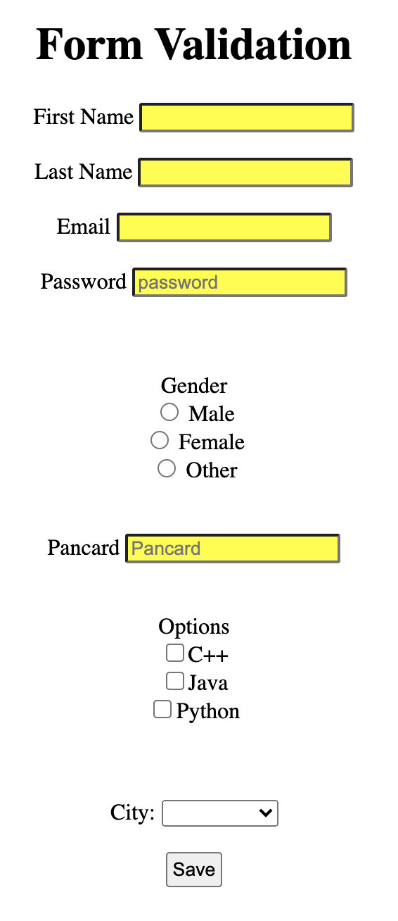 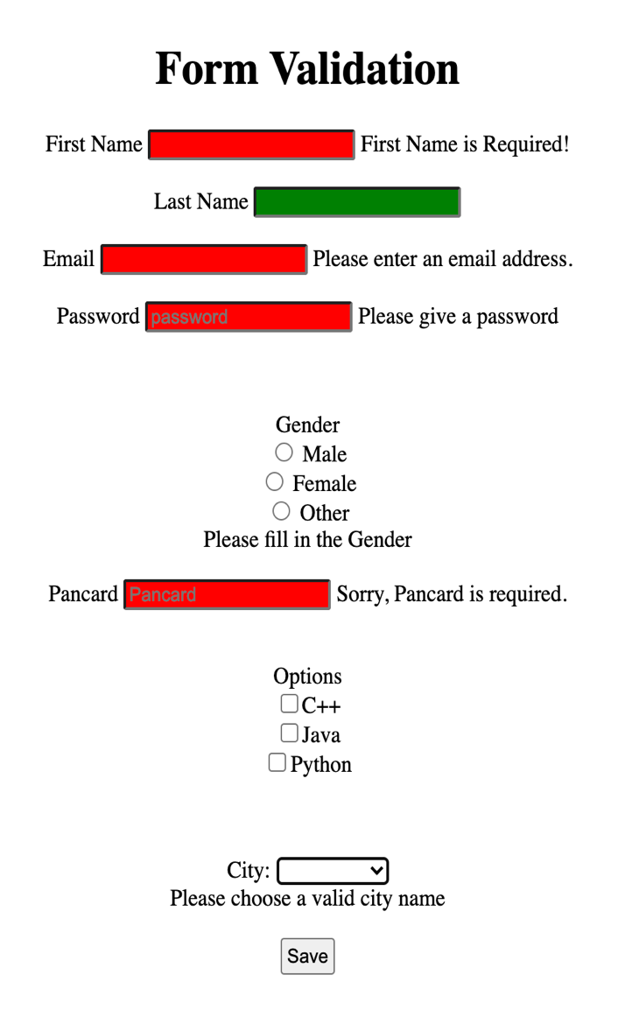

**B.2 Observations/Learning:**

Using business logic, we can create a table in html using angular js and with its ng-repeat directive,   
In form validation we can use $touched and $error attributes to validate the fields of the form.

**B.3 Conclusion:**

Through this experiment I’ve understood the basics of ng-repeat directive and how to create a table using angular js.   
Also, I’ve learned form-validation basics in angular js.

**Experiment 4**

PART B

(PART B: TO BE COMPLETED BY STUDENTS)

**(Students must submit the soft copy as per following segments within two hours of the practical. The soft copy must be uploaded on the Blackboard or emailed to the concerned lab in charge faculties at the end of the practical in case the there is no Black board access available)**

|  |  |
| --- | --- |
| Roll No.: N049 | Name: Tarun Tanmay |
| Program: MBATech CE | Division: B |
| Batch: B3 | Date of Experiment: |
| Date of Submission: | Grade: |

B.1 Output

**Task1)**

**Dependency Injection in Angular JS:**

**Model & Controller:**

<!-- Dependency Injection-->

<!DOCTYPE html>

<html>

<head>

<meta charset="UTF-8">

<meta name="description" text="validation form">

<meta name="viewport" , content="width=device-width, initial-scale=1.0">

<meta name="keywords" content="form, validation, angularJS">

<meta http-equiv="X-UA-Compatible" content="ie-edge">

<!-- Including Angular Java Script -->

<script src="https://ajax.googleapis.com/ajax/libs/angularjs/1.6.9/angular.min.js"></script>

<!-- Linking CSS-->

<link rel="stylesheet" href="task6.css">

<title>

Dependency Injection

</title>

</head>

<body>

<h2> Dependency Injection </h2>

<div class="container" style="padding-top: 20px; padding-left: 20px">

<div ng-app='myApp' ng-controller='myCtrl'>

<p> Roll Number: {{r}}</p>

<p> Result from Service: {{result}}</p>

<p> Result from Factory: {{result1}}</p>

<p> Name from Factory: {{name}}</p>

<p> Result from provider: {{result2}}</p>

<p> Roll Number from provider : {{roll}}</p>

</div>

</div>

<script>

// Definig the Module

var app = angular.module('myApp', []);

//Defining the value

app.value("rollno", 33);

app.constant("roll", 200);

//defining the Service

app.service('myService', function () {

this.add = function (a, b) {

this.sum = a + b;

return this.sum;

};

}

);

//Defining the factory

app.factory('myFactory', function () {

var serviceObj = {};

serviceObj.name = "Factory";

serviceObj.add = function (a, b) {

return a + b;

};

return serviceObj;

}

);

//Defining the Provider

app.provider('configurable', function () {

var results = '';

this.add = function (a, b) {

results = a + b;

};

this.$get = function () {

return {

add: results

};

};

});

// Configuring the Provider

app.config(function (configurableProvider) {

configurableProvider.add(100, 200);

roll = 250;

rollno = 34;

}

);

//Defining the Controller

app.controller('myCtrl', function ($scope, rollno, myService, myFactory, configurable) {

$scope.result = myService.add(34, 45);

$scope.result1 = myFactory.add(30, 40);

$scope.name = myFactory.name;

$scope.r = rollno;

$scope.result2 = configurable.add;

$scope.roll = roll;

}

);

</script>

</body>

</html>

**CSS File:**

body {

text-align: center;

}

h2 {

margin-top: 20rem;

}

.container {

font-size: 1.2rem;

font-family: -apple-system, BlinkMacSystemFont, "Segoe UI", Roboto, Oxygen,

Ubuntu, Cantarell, "Open Sans", "Helvetica Neue", sans-serif;

line-height: 1.2rem;

text-align: center;

}

**View: (Dependency Injection)**

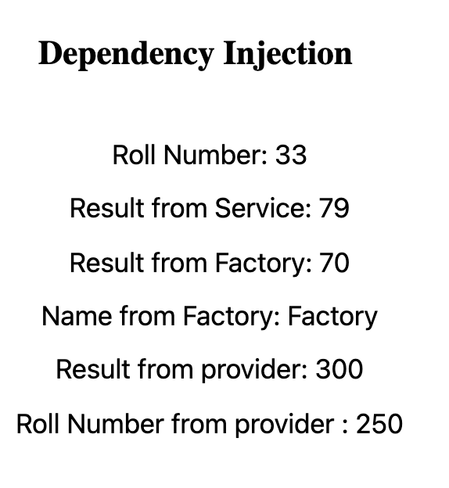

**Task2)**

**Custom Services:**

**Model & Controller:**

<!-- Customised Services-->

<!DOCTYPE html>

<html>

<head>

<meta charset="UTF-8">

<meta name="description" text="validation form">

<meta name="viewport" , content="width=device-width, initial-scale=1.0">

<meta name="keywords" content="form, validation, angularJS">

<meta http-equiv="X-UA-Compatible" content="ie-edge">

<!-- link CSS-->

<link rel="stylesheet" href="Exp4.css">

<!-- Linking Angular -->

<script src="https://ajax.googleapis.com/ajax/libs/angularjs/1.6.9/angular.min.js"></script>

<title>

Customised Services

</title>

</head>

<body ng-app="myApp" ng-controller="myCtrl">

<h2> Customised Services </h2>

<div class="container">

<div>

Message is displayed after 3 seconds: {{msg}}

</div>

<div>

Interval displayed: {{counter}}

</div>

</div>

<button class="btn" ng-click="prompt()">

Display Prompt

</button>

<!-- controller Script -->

<script>

var sample = angular.module('myApp', []);

sample.controller('myCtrl', function ($scope, $timeout, $interval, $window) {

$scope.counter = 0;

$timeout(function () {

$scope.msg = "Hi Tarun!";

}, 3000);

$interval(function () {

$scope.counter = $scope.counter + 1;

}, 1000);

$scope.prompt = function () {

var name = $window.prompt('Enter your Name:');

$window.alert('Hello' + ' ' + name);

}

});

</script>

</body>

</html>

**CSS File:**

body {

background: rgba(51, 51, 51, 0.95);

color: white;

line-height: 3rem;

margin-top: 20rem;

font-style: italic;

font-size: 1.2rem;

font-family: -apple-system, BlinkMacSystemFont, "Segoe UI", Roboto, Oxygen,

Ubuntu, Cantarell, "Open Sans", "Helvetica Neue", sans-serif;

}

.container {

text-align: center;

padding: 1.5rem;

}

.btn {

text-align: center;

padding: 0.5rem;

margin-left: 47.5rem;

font-size: 1.2rem;

}

h2 {

text-align: center;

}

**View: (Customized Services)**

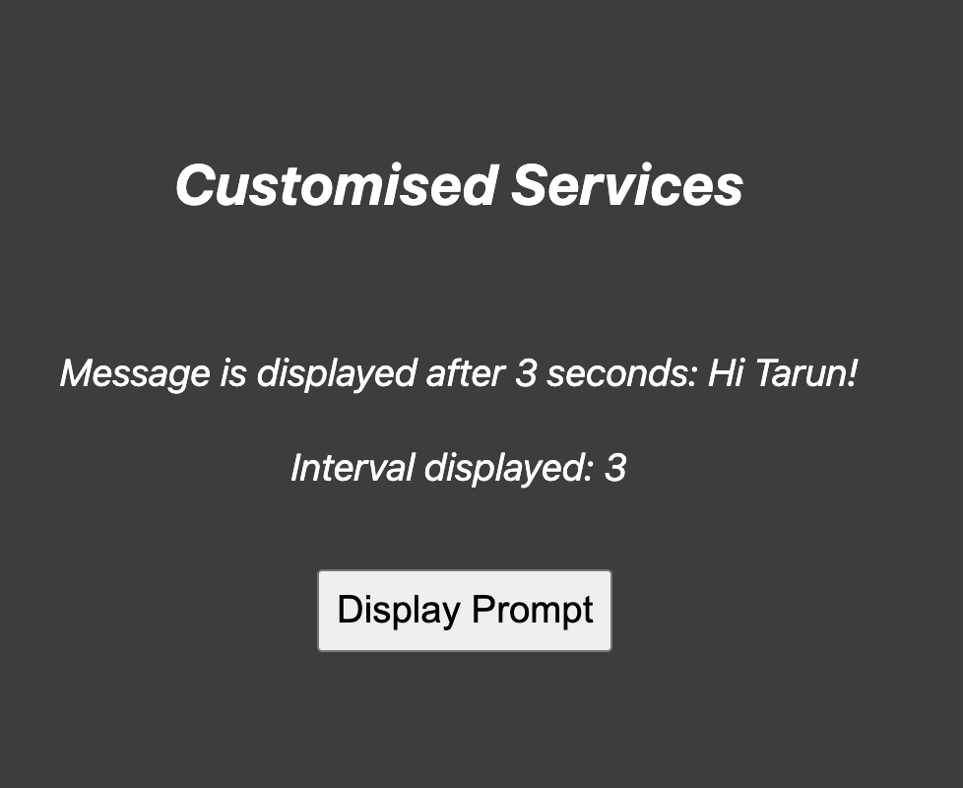

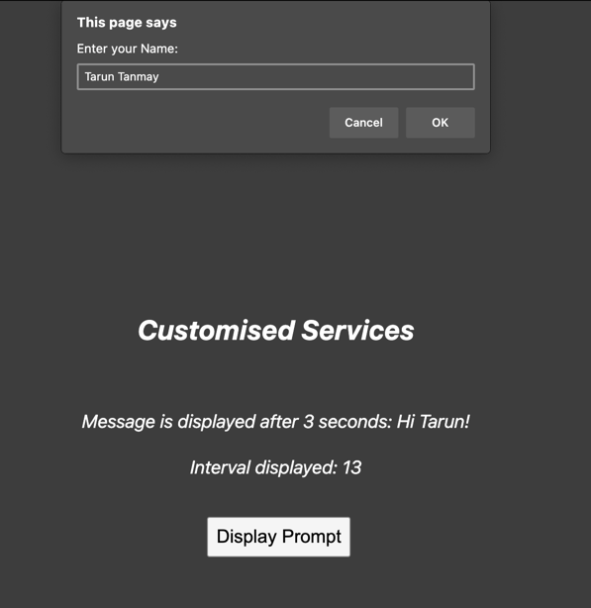 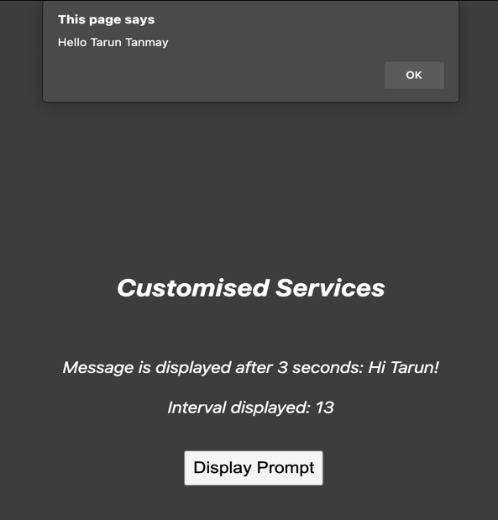

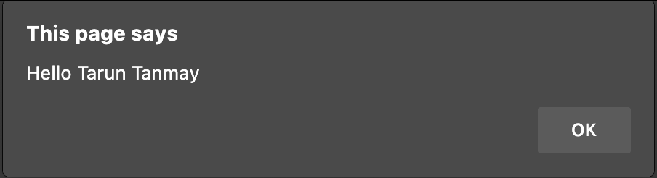 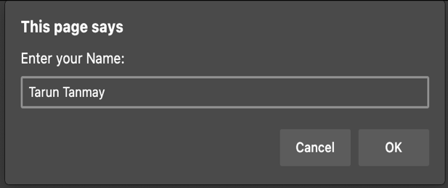

**B.2 Observations/Learning:**

Here I’ve created angular application where there is a business logic with dependency injection that handles the services, configuration, value, constant and services.

Also, I’ve created customized services which will prompt in the view after a certain time, and after fetching input from the user display a message.

**B.3 Conclusion:**

Through this experiment I’ve learned about the dependency injection in angular js, how to define constants and values (variable), service, provider, configuration, and factory. Also, I’ve learned the basics of creating customized services on the web which will be prompted by the browser to fetch user input and display messages.

**Experiment 5**

PART B

(PART B: TO BE COMPLETED BY STUDENTS)

**(Students must submit the soft copy as per following segments within two hours of the practical. The soft copy must be uploaded on the Blackboard or emailed to the concerned lab in charge faculties at the end of the practical in case the there is no Black board access available)**

|  |  |
| --- | --- |
| Roll No.: N049 | Name: Tarun Tanmay |
| Program: MBATech CE | Division: B |
| Batch: B3 | Date of Experiment: |
| Date of Submission: | Grade: |

B.1 Output**:**

**Task1)**

**Parse Student Data stored in Json**

**Model & Controller:**

<!-- MBATech Students JSON Fetch-->

<!DOCTYPE html>

<html>

<head>

<meta charset="UTF-8">

<meta name="description">

<title>

Display Students

</title>

<!-- Linking CSS File -->

<link rel="stylesheet" href="task5.css">

</head>

<body>

<h1 class="head"> Student JSon Data </h1>

<script>

var mba_sem =

{

"students":

[

//student 1

{

"name": "Slim Shady",

"roll:": "Null",

"email": ["Slim.shady2510@gmail.com", "Slimshady0825@gmail.com"]

},

//student2

{

"name": "Eminem",

"roll:": "Null",

"email": ["eminem2510@gmail.com", "eminem0825@gmail.com"]

},

//student3

{

"name": "Marshall Mathers",

"roll:": "46",

"email": ["marshall.mathers2510@gmail.com", "marshallmathers0825@gmail.com"]

},

//student4

{

"name": "White Rabbit",

"roll:": "47",

"email": ["white.rabbit2510@gmail.com", "whiterabbitsingh0825@gmail.com"]

}

]

}

for (x in mba_sem.students) {

if (mba_sem.students[x].name == "Slim Shady") {

mba_sem.students[x].roll = "49"

mba_sem.students[x].name = "Tarun Tanmay"

mba_sem.students[x].email[0] = "tarun.tanmay2510@gmail.com"

mba_sem.students[x].email[1] = "tanmaysingh0825@gmail.com"

}

if (mba_sem.students[x].name == "Eminem") {

mba_sem.students[x].roll = "50"

mba_sem.students[x].email[0] = "eminem.fallout@gmail.com"

}

if (mba_sem.students[x].name == "Marshall Mathers") {

mba_sem.students[x].roll = "51"

}

if (mba_sem.students[x].name == "White Rabbit") {

mba_sem.students[x].roll = "52"

}

document.write("<br> Name:\t" + mba_sem.students[x].name + "\n| Roll No:\t " + mba_sem.students[x].roll +

"\n| Email ID:\t " + mba_sem.students[x].email[0] + " , " + mba_sem.students[x].email[1]);

}

</script>

</body>

</html>

**CSS File:**

body {

text-align: center;

margin-top: 20rem;

padding: 0.2rem;

line-height: 3rem;

font-size: 1.2rem;

font-family: "Gill Sans", "Gill Sans MT", Calibri, "Trebuchet MS", sans-serif;

}

.head {

margin-bottom: 0.1rem;

font-size: 3rem;

font-family: -apple-system, BlinkMacSystemFont, "Segoe UI", Roboto, Oxygen,

Ubuntu, Cantarell, "Open Sans", "Helvetica Neue", sans-serif;

}

**View: (Student Data stored in Json):**

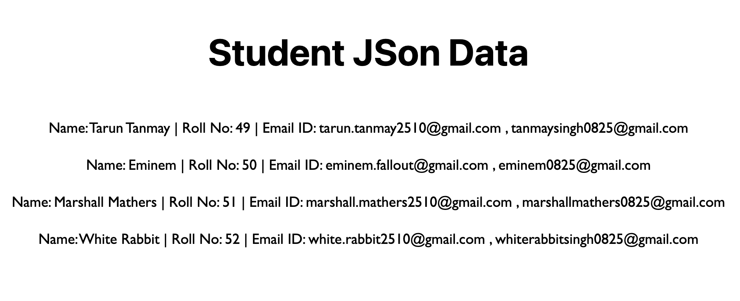

**Task2)**

**(Html Table for Student Data stored in Json with Ajax)**

**Method1: Fetch from PHP**

**Model & Controller:**

<!-- JSONp Runner-->

<!DOCTYPE html>

<html>

<head>

<meta charset="utf-8">

<meta name="description" text="validation form">

<meta name="viewport" , content="width=device-width, initial-scale=1.0">

<meta name="keywords" content="form, validation, angularJS">

<!-- Including Angular Java Script -->

<script src="https://ajax.googleapis.com/ajax/libs/angularjs/1.6.9/angular.min.js"></script>

<!-- Linking CSS -->

<link rel="stylesheet" href="task7.css">

<title>

JSONp HTML

</title>

</head>

<body>

<h2> JSONp HTML </h2>

<p> Php file is returning a call to the myFunc function</p>

<button class="btn" onclick="clickButton()"> Click Here</button>

<div class="showcase">

<div class="name">

<table>

<tr>

<th> Name </th>

<tr id="name"> </tr>

</tr>

</table>

</div>

<div class="roll">

<table>

<tr>

<th> Roll No. </th>

<tr id="roll"> </tr>

</tr>

</table>

</div>

<div class="email">

<table>

<tr>

<th> Email </th>

<tr id="email"> </tr>

</tr>

</table>

</div>

</div>

<!-- CallBack Function -->

<!-- Sourcing the php file-->

<script>

function clickButton() {

var b = document.createElement("script");

b.src = "http://localhost/AWP_htdocs/task7.php?callback=myFunc";

document.body.appendChild(b);

//.appendChild and .createELement are DOM functions

}

function myFunc(myObj) {

document.getElementById("name").innerHTML = myObj.name;

document.getElementById("roll").innerHTML = myObj.roll;

document.getElementById("email").innerHTML = myObj.email;

//.innerHTML changes the content

}

</script>

</body>

</html>

**CSS File:**

body {

text-align: center;

margin-top: 20rem;

font-family: -apple-system, BlinkMacSystemFont, "Segoe UI", Roboto, Oxygen,

Ubuntu, Cantarell, "Open Sans", "Helvetica Neue", sans-serif;

font-size: 1.5rem;

}

.showcase {

text-align: center;

margin-left: 38rem;

}

h2 {

font-size: 2rem;

}

table,

th {

text-align: center;

font-size: 1.2rem;

padding: 0.5rem;

font-family: -apple-system, BlinkMacSystemFont, "Segoe UI", Roboto, Oxygen,

Ubuntu, Cantarell, "Open Sans", "Helvetica Neue", sans-serif;

border: 4px solid black;

border-collapse: collapse;

}

.showcase {

align-items: center;

}

.name {

align-items: center;

margin-left: 100px;

}

.roll {

align-items: center;

margin-top: -83px;

margin-left: 230px;

}

.email {

align-items: center;

margin-left: 325px;

margin-top: -83px;

}

#name {

margin-left: 60px;

font-size: 1.2rem;

line-height: 2.2rem;

padding: 1rem;

font-family: -apple-system, BlinkMacSystemFont, "Segoe UI", Roboto, Oxygen,

Ubuntu, Cantarell, "Open Sans", "Helvetica Neue", sans-serif;

}

#roll {

font-size: 1.2rem;

line-height: 2.2rem;

padding: 1rem;

font-family: -apple-system, BlinkMacSystemFont, "Segoe UI", Roboto, Oxygen,

Ubuntu, Cantarell, "Open Sans", "Helvetica Neue", sans-serif;

}

#email {

font-size: 1.2rem;

line-height: 2.2rem;

padding: 1rem;

font-family: -apple-system, BlinkMacSystemFont, "Segoe UI", Roboto, Oxygen,

Ubuntu, Cantarell, "Open Sans", "Helvetica Neue", sans-serif;

}

.btn {

font-size: 1.2rem;

margin-bottom: 1.5rem;

}

**PHP File:**

<?php

$myJSON = '{"name":"Tarun Tanmay", "roll":"N049", "email":"tarun.tanmay2510@gmail.com"}';

echo "myFunc(".$myJSON.")";

?>

**View:**

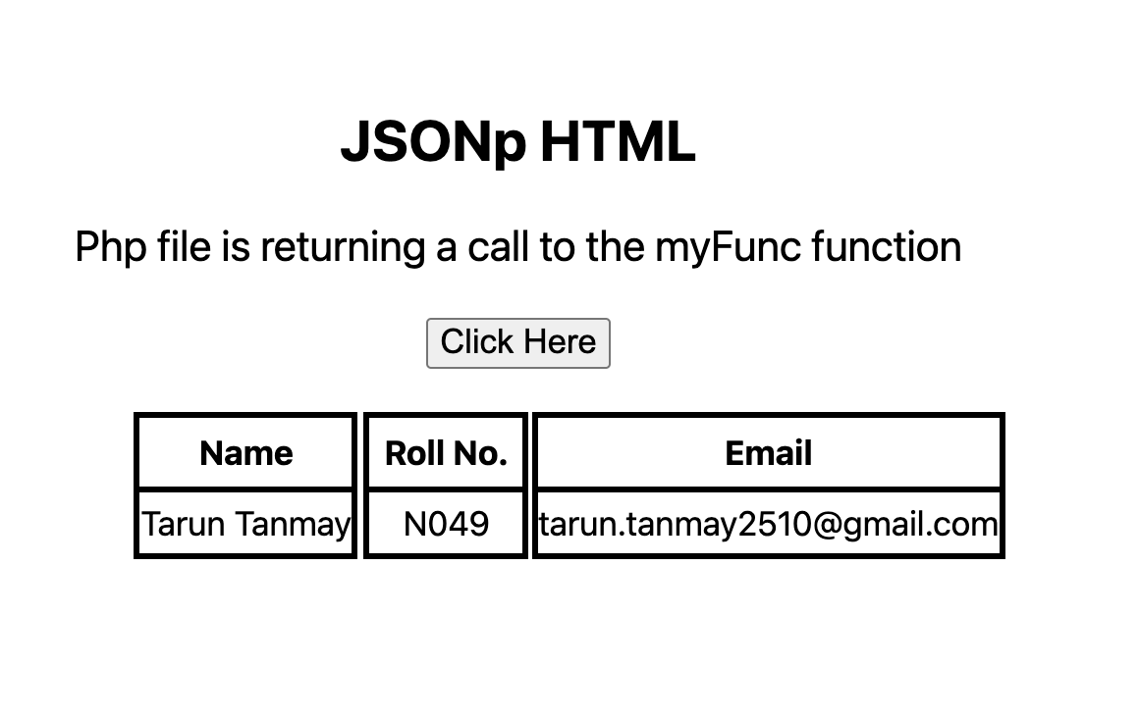

**Method 2:**

**Fetch from external Json File  
  
Model & Controller:**

<!-- External Json fetch -->

<!-- Ajax with Json -->

<!DOCTYPE html>

<html>

<head>

<meta charset="UTF-8">

<meta name="viewport" , content="width=device-width, initial-scale=1.0">

<meta name="description" text="N049_Assignment1">

<meta http-equiv="X-UA-Compatible" content="ie-edge">

<meta name="keywords" content="json,html">

<!--Title-->

<title>

Nutritionist

</title>

<style>

div {

font: 24px 'Anaheim';

padding: 2px 30px;

line-height: 45px;

}

#heading {

font-family: Impact, Haettenschweiler, 'Arial Narrow Bold', sans-serif;

}

table,

tr,

td {

margin-top: 10px;

border: 1px solid;

border-collapse: collapse;

text-align: center;

padding: 5px;

}

</style>

</head>

<body>

<div id="heading">

<h1>HealthifyUs</h1>

</div>

<div id="table1"></div>

</body>

<script>

var oXHR = new XMLHttpRequest();

oXHR.onreadystatechange = reportStatus;

oXHR.open("GET", "http://localhost/AWP_htdocs/nutrition.json", true); //get json file

oXHR.send();

function reportStatus() {

if (oXHR.readyState == 4) { //check if request is complete.

createTable(this.responseText);

}

}

function createTable(jsonData) {

var food = [];

food = JSON.parse(jsonData);

var columns = [];

var j;

for (var i = 0; i < food.length; i++) {

for (j in food[i]) {

if (columns.indexOf(j) === -1) {

columns.push(j);

}

}

}

var table = document.createElement("table");

// create header row

var tr = table.insertRow();

var tabCell;

var k = 0;

for (var j = 0; j < columns.length; j++) {

tabCell = tr.insertCell(j);

tabCell.innerHTML = columns[j];

}

// Add JSON values to the rows

for (var i = 0; i < food.length; i++) {

var tr = table.insertRow();

for (var j = 0; j < columns.length; j++) {

tabCell = tr.insertCell(j);

if (columns[j] == "vitamins" || columns[j] == "minerals") {

for (var f = 0; f < food[i][columns[j]].length; f++) {

for (var n in food[i][columns[j]][f]) {

tabCell.innerHTML += n + ":" + food[i][columns[j]][f][n] + " ";

}

}

}

else {

tabCell.innerHTML = food[i][columns[j]];

}

}

}

// Add table to container

var container = document.getElementById("table1");

container.innerHTML = "";

container.appendChild(table);

}

</script>

</html>

**CSS File:**

div {

font: 17px "Calibri";

}

table,

th,

td {

border: solid 1px #ddd;

border-collapse: collapse;

padding: 2px 3px;

text-align: center;

}

th {

font-weight: bold;

}

**Json File:**

[

{

"name": "avacado",

"serving_units":"g29",

"calories_total":"70",

"carb":"2",

"vitamins":[{"a":6},{"c":0}],

"minerals":[{"ca":2},{"fe":4}]

},

{

"name": "eggs",

"serving_units":"g50",

"calories_total":"70",

"carb":"2",

"vitamins":[{"a":6},{"c":0}],

"minerals":[{"ca":2},{"fe":4}]

},

{

"name": "veg stew",

"serving_units":"g29",

"calories_total":"70",

"carb":"2",

"vitamins":[{"a":6},{"c":0}],

"minerals":[{"ca":2},{"fe":4}]

},

{

"name": "potato fries",

"serving_units":"g29",

"calories_total":"70",

"carb":"2",

"vitamins":[{"a":6},{"c":0}],

"minerals":[{"ca":2},{"fe":4}]

},

{

"name": "salads",

"serving_units":"g6",

"calories_total":"7",

"carb":"2",

"vitamins":[{"a":6},{"c":0}],

"minerals":[{"ca":2},{"fe":4}]

}

]

**View:**

**B.2 Observations/Learning:**

Here, I’ve displayed student json data on the browser by parsing it to the created application.

Here, I’ve fetched the json format data in a php file and displayed it in the form of a table on the browser.

Also, I’ve created an application to display HTML Table after fetching json data with ajax.

**B.3Conclusion:**

In this experiment I’ve learned the basics of json and parsing of json files, along with creating html table of json data with ajax.

**Experiment 6**

PART B

(PART B: TO BE COMPLETED BY STUDENTS)

**(Students must submit the soft copy as per following segments within two hours of the practical. The soft copy must be uploaded on the Blackboard or emailed to the concerned lab in charge faculties at the end of the practical in case the there is no Black board access available)**

|  |  |
| --- | --- |
| Roll No.: N049 | Name: Tarun Tanmay |
| Program: MBATech CE | Division: B |
| Batch: B3 | Date of Experiment: |
| Date of Submission: | Grade: |

**B.1 Output:**

**Task1)**

**(Parsing XML File with XMLHttpRequest Object)**

**Model & Controller:**

<!-- XML AJAX-->

<!DOCTYPE html>

<html>

<head>

<meta charset="utf-8">

<meta name="description" text="validation form">

<meta name="viewport" , content="width=device-width, initial-scale=1.0">

<meta name="keywords" content="form, validation, angularJS">

<!-- Including Angular Java Script -->

<script src="https://ajax.googleapis.com/ajax/libs/angularjs/1.6.9/angular.min.js"></script>

<!-- Linking CSS-->

<link rel=" stylesheet" href="task8.css">

<title>

XML AJAX

</title>

</head>

<body>

<h2> XML AJAX Fetch </h2>

<div class="showcase">

<div class="name">

<table>

<tr>

<th> Name </th>

<tr id="content"> </tr>

</tr>

</table>

</div>

<div class="roll">

<table>

<tr>

<th> Roll No. </th>

<tr id="details"> </tr>

</tr>

</table>

</div>

<div class="Course">

<table>

<tr>

<th> Course </th>

<tr id="Course"> </tr>

</tr>

</table>

</div>

</div>

<!-- Name SCRIPT -->

<script>

var xhttp, xDoc, xtxt, x, i;

xhttp = new XMLHttpRequest();

xhttp.onreadystatechange = function () {

xDoc = this.responseXML;

xtxt = "";

x = xDoc.getElementsByTagName("NAME");

for (i = 0; i < x.length; i++) {

xtxt += x[i].childNodes[0].textContent + "<br>";

}

document.getElementById("content").innerHTML = xtxt;

};

xhttp.open("GET", "task8.xml", true);

xhttp.send();

</script>

<!-- Details Script -->

<script>

var xhttp, xDoc, xtxt, x, i;

xhttp = new XMLHttpRequest();

xhttp.onreadystatechange = function () {

xDoc = this.responseXML;

xtxt = "";

x = xDoc.getElementsByTagName("Roll");

for (i = 0; i < x.length; i++) {

for (j = 0; j < x[i].childNodes.length; j++) {

xtxt += x[i].childNodes[j].textContent + "<br>";

}

}

document.getElementById("details").innerHTML = xtxt;

};

xhttp.open("GET", "task8.xml", true);

xhttp.send();

</script>

<!-- Course Script -->

<script>

var xhttp, xDoc, xtxt, x, i;

xhttp = new XMLHttpRequest();

xhttp.onreadystatechange = function () {

xDoc = this.responseXML;

xtxt = "";

x = xDoc.getElementsByTagName("Course");

for (i = 0; i < x.length; i++) {

for (j = 0; j < x[i].childNodes.length; j++) {

xtxt += x[i].childNodes[j].textContent + "<br>";

}

}

document.getElementById("Course").innerHTML = xtxt;

};

xhttp.open("GET", "task8.xml", true);

xhttp.send();

</script>

</body>

</html>

**CSS File:**

body {

margin-top: 150px;

padding: 2rem;

margin-left: 650px;

}

h2 {

margin-left: 75px;

font-size: 1.8rem;

}

#content {

font-size: 1.2rem;

line-height: 2.2rem;

padding: 1rem;

font-family: -apple-system, BlinkMacSystemFont, "Segoe UI", Roboto, Oxygen,

Ubuntu, Cantarell, "Open Sans", "Helvetica Neue", sans-serif;

}

#details {

font-size: 1.2rem;

line-height: 2.2rem;

padding: 1rem;

font-family: -apple-system, BlinkMacSystemFont, "Segoe UI", Roboto, Oxygen,

Ubuntu, Cantarell, "Open Sans", "Helvetica Neue", sans-serif;

}

#Course {

font-size: 1.2rem;

line-height: 2.2rem;

padding: 1rem;

font-family: -apple-system, BlinkMacSystemFont, "Segoe UI", Roboto, Oxygen,

Ubuntu, Cantarell, "Open Sans", "Helvetica Neue", sans-serif;

}

table,

th {

text-align: center;

font-size: 1.2rem;

padding: 0.5rem;

font-family: -apple-system, BlinkMacSystemFont, "Segoe UI", Roboto, Oxygen,

Ubuntu, Cantarell, "Open Sans", "Helvetica Neue", sans-serif;

border: 4px solid black;

border-collapse: collapse;

}

.showcase {

align-items: center;

}

.name {

align-items: center;

}

.roll {

align-items: center;

margin-left: 155px;

margin-top: -186px;

}

.Course {

align-items: center;

margin-left: 255px;

margin-top: -186px;

}

**XML FILE:**

<College>

<!-- student 1-->

<student>

<NAME> TARUN TANMAY </NAME>

<Roll> N049 </Roll>

<Course> IBM </Course>

</student>

<!-- student 2-->

<student>

<NAME> JAI VERMA </NAME>

<Roll> N060 </Roll>

<Course> UDEMY </Course>

</student>

<!-- Student 3 -->

<student>

<NAME> Snehil Shuman </NAME>

<Roll> N047 </Roll>

<Course> COURSERA </Course>

</student>

<!-- Student 4-->

<student>

<NAME> Vaibhav Soni </NAME>

<Roll> N046 </Roll>

<Course> EDX </Course>

</student>

</College>

**View: (Student Table XML AJAX)**

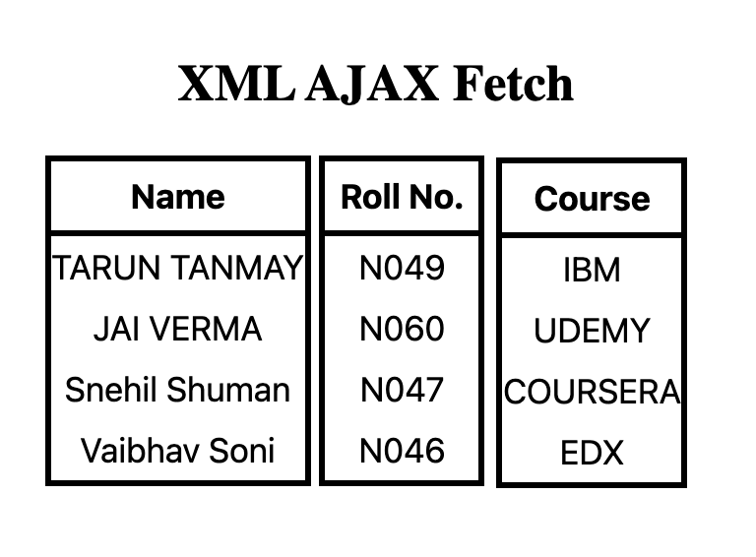

**Task2)**

**GET & POST Request Methods in AJAX:**

**Model & Controller:**

<!-- AJAX GET & POST -->

<!DOCTYPE html>

<html>

<meta charset="UTF-8">

<meta name="viewport" , content="width=device-width, initial-scale=1.0">

<meta name="description" text="Ajax">

<meta http-equiv="X-UA-Compatible" content="ie-edge">

<head>

<title>

AJAX GET & POST

</title>

<!-- Linking CSS -->

<link rel="stylesheet" href="Exp6.css">

</head>

<body>

<h2> AJAX GET & POST </h2>

<form class="form">

Name: <input class="entry" type="text" id="txt_name"> <br>

Roll No: <input class="entry" type="text" id="txt_roll"> <br>

Email: <input class="entry" type="email" id="txt_email"> <br>

<input type="button" id="btn_submit" value="Submit!" onclick="insertNewStudent();">

</form>

<p id="details"> Student Data: <br> </p>

<!-- Controller Script -->

<script>

// Loading Records with Get request

function loadStudents(name, roll, email) {

var xhttp = new XMLHttpRequest();

//setting Get method, and Ajax file path

xhttp.open("GET", "http://localhost/AWP_htdocs/Exp6.php?request= " + "<br>" + name + "<br>" + roll + "<br>" + email + "<br>" + "<br>", true);

//Content-Type

xhttp.setRequestHeader('Content-type', 'application/x-www-form-urlencoded');

//Call on Request changes state

xhttp.onreadystatechange = function () {

if (this.readyState == 4 && this.status == 200) {

var myObj = (this.responseText);

document.getElementById("details").innerHTML += " " + myObj;

}

};

//Send Request

xhttp.send();

}

function insertNewStudent() {

var name = document.getElementById('txt_name').value;

var roll = document.getElementById('txt_roll').value;

var email = document.getElementById('txt_email').value;

if (name != '' && roll != '' && email != '') {

var data = { name: name, roll: roll, email: email };

var xhttp = new XMLHttpRequest();

//Setting POST Method, and AJAX PAth

xhttp.open("POST", "http://localhost/AWP_htdocs/Exp6.php", true);

//Call on request changes state

xhttp.onreadystatechange = function () {

if (this.readyState == 4 && this.status == 200) {

console.log(this.responseText);

loadStudents(name, roll, email);

}

};

//Content-Type

xhttp.setRequestHeader("Content-Type", "application/json");

console.log(JSON.stringify(data));

//Send request with data

xhttp.send(JSON.stringify(data));

}

}

</script>

</body>

</html>

**CSS File:**

body {

text-align: center;

padding: 2rem;

margin-top: 20px;

font-size: 1.5rem;

}

.form {

line-height: 2rem;

font-family: -apple-system, BlinkMacSystemFont, "Segoe UI", Roboto, Oxygen,

Ubuntu, Cantarell, "Open Sans", "Helvetica Neue", sans-serif;

font-size: 1.2rem;

padding: 1rem;

}

#btn_submit {

font-size: 1.5rem;

margin-top: 1rem;

padding: 0.2rem;

}

.entry {

font-size: 1rem;

font-family: -apple-system, BlinkMacSystemFont, "Segoe UI", Roboto, Oxygen,

Ubuntu, Cantarell, "Open Sans", "Helvetica Neue", sans-serif;

line-height: 1.2rem;

margin-top: 0.3rem;

padding: 0.1rem;

}

#details {

line-height: 1.2rem;

font-size: 1.2rem;

padding: 0.4rem;

font-family: -apple-system, BlinkMacSystemFont, "Segoe UI", Roboto, Oxygen,

Ubuntu, Cantarell, "Open Sans", "Helvetica Neue", sans-serif;

}

**PHP File:**

<?php

if(isset($_GET['request']))

{

$request=$_GET['request'];

$obj=explode(" ",$request);

$s=" ";

foreach ($obj as $o)

{

$s=$s.$o;

}

echo $s;

}

else

{

$data=(json_decode(file_get_contents('php://input'), true));

$name=$data["name"];

$roll=$data["roll"];

$email=$data["email"];

print_r($name);

print_r($roll);

print_r($email);

}

?>

**View:**

**(Ajax Get & Post)**

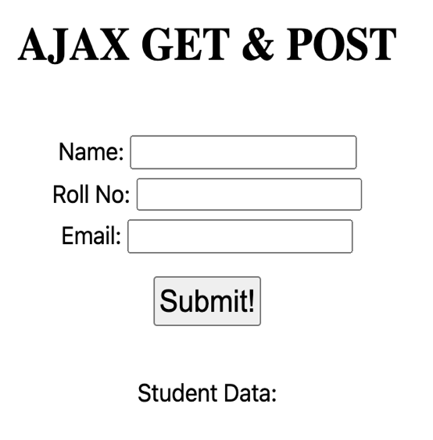 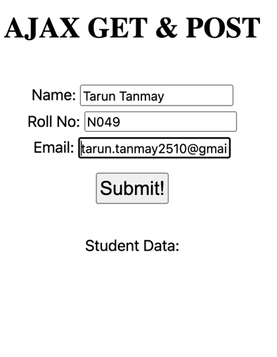

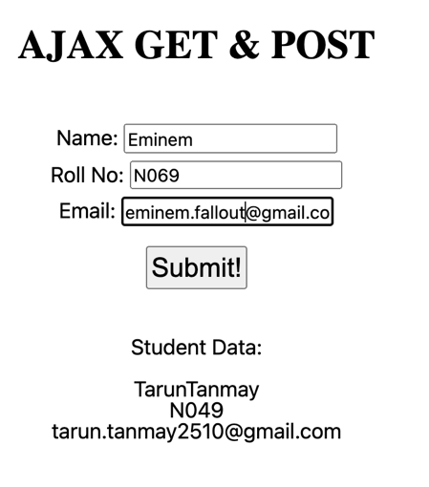 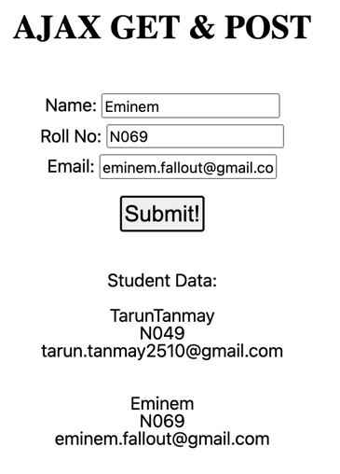

**B.2) Observations/Learning:**

I’ve parsed XML file with HTTP Request Object and also created an application where I’ve used GET and POST methods to fetch and display data on the browser.

**B.3) Conclusion:**

In this experiment, I’ve learned how to parse XML data using ajax and the basics of using Get and Post method implementation in ajax.

**Experiment 7**

PART B

(PART B: TO BE COMPLETED BY STUDENTS)

**(Students must submit the soft copy as per following segments within two hours of the practical. The soft copy must be uploaded on the Blackboard or emailed to the concerned lab in charge faculties at the end of the practical in case the there is no Black board access available)**

|  |  |
| --- | --- |
| Roll No.: N049 | Name: Tarun Tanmay |
| Program: | Division: |
| Batch: | Date of Experiment: |
| Date of Submission: | Grade: |

B.1 Output**:**

**Task1)**

**Implementing Node Js Calculator:**

**Calculator.js**

//importing the export module

var c = require('./calculatormodule');

//importing the prompt module, to give user input

const val = require('prompt')

//getting input from the user

val.get(['a','b'], function(err,result)

{

if(err)

{

return onerror(err);

}

//converting numbers a&b into Int datatype

a = parseInt(result.a, 10);

b=parseInt(result.b, 10);

//displaying arithmetic solutions

console.log("Addition: "+c.addition(a,b));

console.log("Subtraction: "+c.subtraction(a,b));

console.log("Multiplication: "+c.multiplication(a,b));

console.log("Division: "+c.division(a,b));

});

//defining a function to handle errors

function onerror(err)

{

console.log(err);

return 1;

}

**Calculatormodule.js**

//Calculator Application

//a & b are the variables which we are using

// a&b will take values of user input

//Addition

exports.addition = function (a,b)

{

return a+b;

};

//Subtraction

exports.subtraction = function(a,b)

{

return a-b;

};

//Multiplication

exports.multiplication = function(a,b)

{

return a*b;

};

//Division

exports.division = function(a,b)

{

return a/b;

};

**Output:**

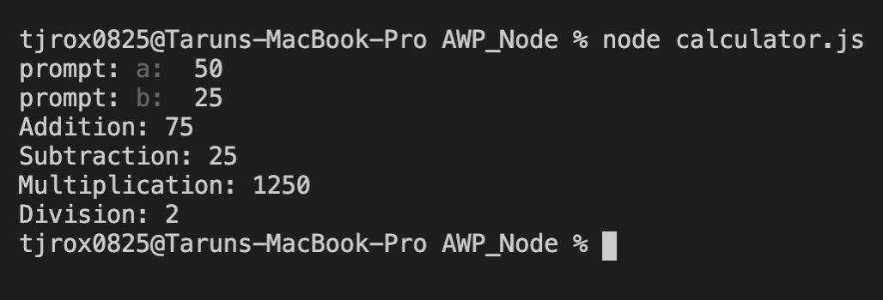

**Task2)**

**HTTP Module**

**Httpmodule.js**

// Including http and url module in the file

var http = require('http');

var url = require('url');

//creating a http server

http.createServer(function(req,res)

{

//Writing response Header

//content type indicates the response content type

res.writeHead(200, {'Content-Type': 'text/html'});

//200 indicates the okay status

//writing to response message body

res.write('Node.js http module started! <br/> <br/>');

//true there means they are set to be decomposed

var q = url.parse(req.url, true).query;

//storing full name in txt named variable

var txt= q.firstname + " "+q.lastname;

//writing to repsonse body again

res.write("Name: " + " " +txt);

//ending the response

res.end();

}).listen(9001);

console.log("Server is running at port 9001");

**Output:**



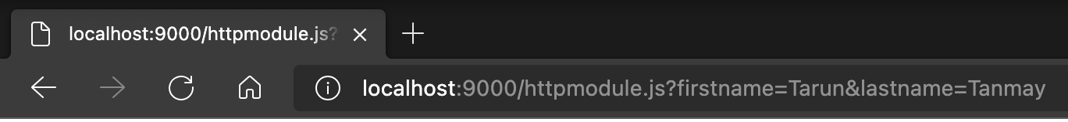

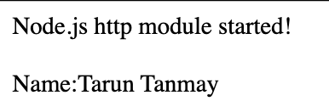

**B.2 Observations/Learning:**

I’ve created calculator module which defines functioning of the calculator application in node js, also I’ve created an application using http module which creates a server and responds to query, displayed on the browser.

**B.3 Conclusion:**

In this experiment, I’ve successfully created a node js application which imports the user defined calculator module and inbuilt http module to create server and write response on the browser.

**Experiment 8**  
  
PART B

(PART B: TO BE COMPLETED BY STUDENTS)

**(Students must submit the soft copy as per following segments within two hours of the practical. The soft copy must be uploaded on the Blackboard or emailed to the concerned lab in charge faculties at the end of the practical in case the there is no Black board access available)**

|  |  |
| --- | --- |
| Roll No.: N049 | Name: Tarun Tanmay |
| Program: MBATech CE | Division: B |
| Batch: B3 | Date of Experiment: |
| Date of Submission: | Grade: |

**B.1 Output:**

**Task1)**

**URL Module in Node JS**

**Urlmodule.js:**

//importing the url module

var url = require('url');

//fetching the address

var adr = 'http://localhost:8080/default.html?year=2021&month=april';

//converting string into object

//parsing the data

var q = url.parse(adr, true);

//output: host

console.log(q.host);

//output: pathname of the url

console.log(q.pathname);

//output: seacrh query

console.log(q.search);

//finding the query month

var qdata = q .query;

console.log(qdata.month);

**Output:**

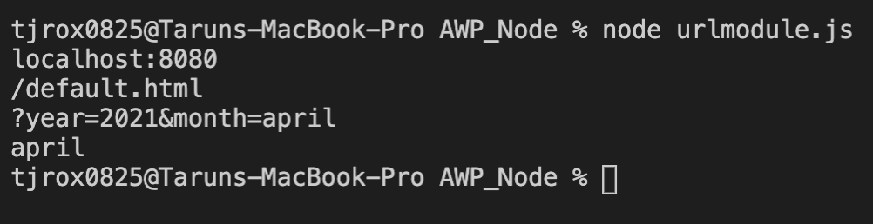

**Task2)**

**FS Module in Node Js**

**Method 1:**

**Filemodule.js:**

//filemodule.js file: Importing fs module

var fs = require('fs');

//read functionality:

fs.readFile('sample_http.txt',function(err,data)

{

if(err)

{

return console.error(err);

}

console.log(data.toString());

});

//reading the data from the sample file

var data = fs.readFileSync('sample_http.txt');

console.log("Synchronous Read: " + data.toString());

//writing data to sample file

console.log("Writing into existing file");

fs.writeFile('sample_http.txt', 'This is node.js and we are implemneting fs write', 'utf8', function(err,data){

if (err)

{

return console.error(err);

}

console.log("Data written Successfully!");

//fs read

fs.readFile('sample_http.txt', function(err,data1)

{

if (err)

{

return console.error(err);

}

console.log("Asynchronous Read:" + data1.toString());

});

});

var data2= "\n Learn Node.js \n";

//fs append

fs.appendFile('sample_http.txt', data2, 'utf8', function(err)

{

if (err) throw err;

// if no error

console.log("Data is appended to file successfully!");

});

**Sample_http.txt:**

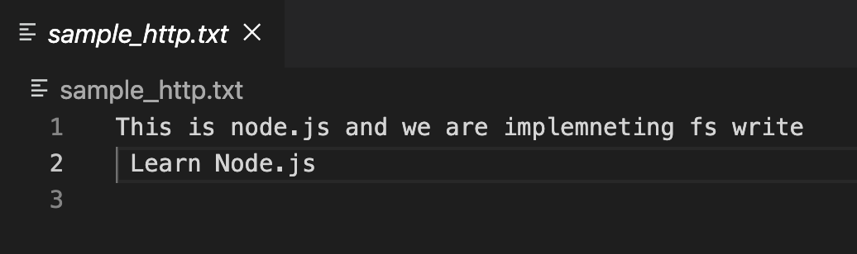

**Output:**

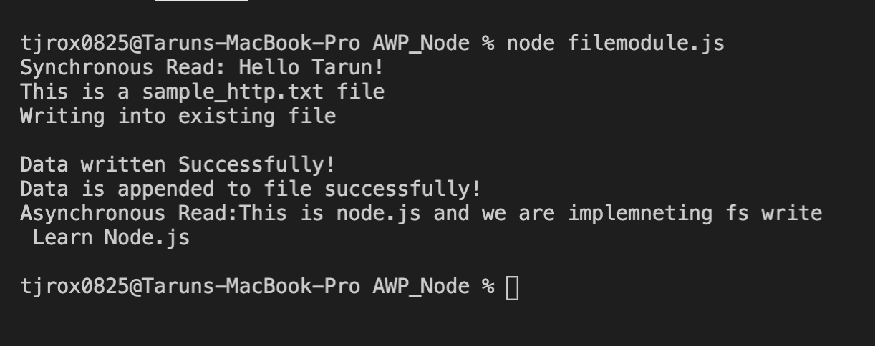

**Method 2:**

**fsurl.js:**

//importing the file system module

var http = require("http");

var fs = require("fs");

const url = require("url");

//fs read

const readdata = fs.readFileSync( //synchronous read

"sample_http.txt",

"utf8",

function (err, data) {

console.log(data.to);

},

);

console.log(

"Writing in existing file",

);

fs.writeFileSync( // synchronous write

"sample_http.txt",

"Sample text is taking over.",

"utf8",

function (err, data1) {

if (err) {

return console.error(

err,

);

}

console.log(

"Data written successfully",

);

//fs read

/* fs.readFile(

"Sample.txt",

function (err, data1) {

if (err) {

return console.error(

err,

);

}

console.log(

"Asynchronous read: " +

data1.toString(),

);

},

); */

},

);

var appenddata =

"\nNew demonstrations have taken over old ones.";

fs.appendFile( //appending the file with the new data

"Sample.txt",

appenddata,

"utf8",

function (err) {

if (err) throw err;

console.log(

"Data is appended to file successfully",

);

},

);

http

.createServer(

(req, res) => {

res.writeHead(200, {

"Content-Type":

"text/plain",

});

res.write(readdata);

res.end();

},

).listen(9002);

console.log("Server is listening at 9002!")

**Output:**

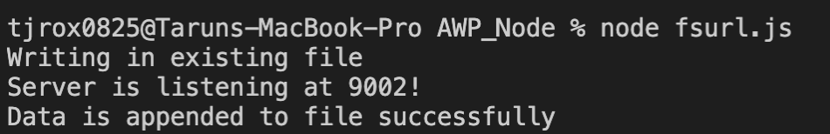

**Sample_http.txt:**

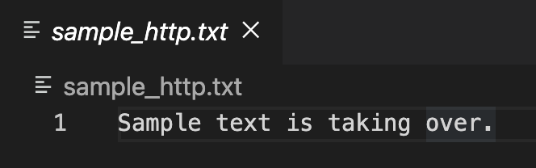

**Sample.txt:**

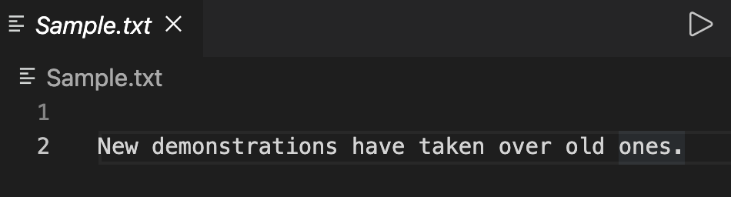

**Browser:**

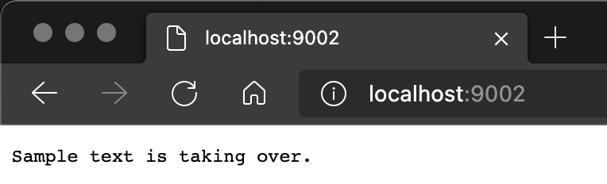

**B.2 Observations/Learning:**

Here, I’ve successfully created a node js application in which url module to fetch the address and parse that data in form of query, answered by the url function.

Also, I’ve created an application in node js in which I’m using fs module functions to read data from and write & append to sample_http.txt file, this has implemented through synchronous read and write functions of fs module in Node JS.

**B.3Conclusion:**

In this experiment I’ve learned about different types of file handling functions such as fs read, write, append, and asynchronous read. I’ve successfully implemented different types of FS modules and learned about text manipulation in Node Js.

**Experiment 9**  
  
PART B

(PART B: TO BE COMPLETED BY STUDENTS)

**(Students must submit the soft copy as per following segments within two hours of the practical. The soft copy must be uploaded on the Blackboard or emailed to the concerned lab in charge faculties at the end of the practical in case the there is no Black board access available)**

|  |  |
| --- | --- |
| Roll No.: N049 | Name: Tarun Tanmay |
| Program: MBATech CE | Division: B |
| Batch: B3 | Date of Experiment: |
| Date of Submission: | Grade: |

**B.1 Output:**

**Crud Operations using MySQL and Node js:**

**Createdatabase.js:**

var mysql = require('mysql');

var readlineSync = require('readline-sync');

var con = mysql.createConnection({ //creating the connection to the database

host: "localhost",

user: "root",

password: "password",

database: 'mydb'

});

con.connect(function(err) {

if (err) throw err;

console.log("Connected!"); // console if the database is connected

con.query("CREATE DATABASE mydb3", function (err, result) { // creating the database

if (err) throw err;

console.log("Database created");

});

});

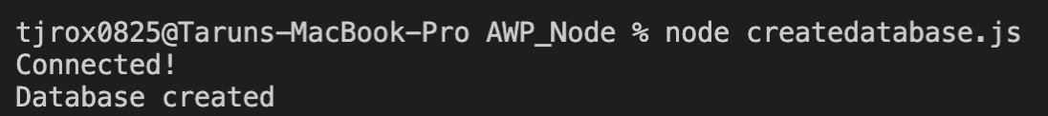

**Mysql.js:**

var mysql = require('mysql');

var readlineSync = require('readline-sync');

var con = mysql.createConnection({

host: "localhost",

user: "root",

password: "password",

port:3306,

database:'mydb',

});

con.connect(function(err) {

if (err) throw err;

console.log("Connected!");

var sql = "Create table if not exists Employee(emp_id int primary key,empname varchar(25),dept_id int,salary int);";

//"CREATE TABLE if not exists Employee(emp_id INT PRIMARY KEY ,emp_name VARCHAR(255),department_id INT PRIMARY KEY NOT NULL,Salary VARCHAR(255))"

con.query(sql, function (err, result) {

if (err) throw err;

console.log("Table Employee created"); // alerting user of the creation of the table

});

var sql = "Create table if not exists Department(dept_id int references employee(dept_id),deptname varchar(25),Location VARCHAR(255))";

//"CREATE TABLE if not exists Department( department_id INT ,CONSTRAINT fk_category FOREIGN KEY (department_id) REFERENCES Employee(department_id) ,dep_name VARCHAR(255),Location VARCHAR(255) )"

con.query(sql, function (err, result) {

if (err) throw err;

console.log("Table Department created");

});

var rows=readlineSync.question('How many records do you want to insert?'); // CREATE Operation

for (let i = 0; i < rows; i++)

{

var eid = readlineSync.question('Enter emp_id:');

var name = readlineSync.question('Enter Employee name:');

var did = readlineSync.question('Enter department_id:');

var sal = readlineSync.question('Enter Salary:');

var values_e = [[eid,name,did,sal]]; // creating an array for the employee table

var dn = readlineSync.question('Enter Department name:');

var loc = readlineSync.question('Enter Location:');

var values_d = [[did,dn,loc]]; // creating an array for the department infromation

var sql = "INSERT INTO Employee VALUES?";

con.query(sql,[values_e],function (err, result) {

if (err) throw err;

console.log("Number of records inserted into Employee: " + result.affectedRows); // number of entries

//in the employee table

});

var sql = "INSERT INTO Department VALUES?";

con.query(sql,[values_d],function (err, result) {

if (err) throw err;

console.log("Number of records inserted into Department: " + result.affectedRows);

//number of entries in the department table

});

}

con.query("SELECT * FROM Employee", function (err, result, fields) { // READ Operation

if (err) throw err;

console.log(result); // displaying the entire record

});

var sql = "UPDATE Employee SET empname = 'UPDATED Sample3' WHERE emp_id = '03'"; // UPDATE Operation

//When the employee id is 03, the name should be updated to 'UPDATED Sample3'

con.query(sql, function (err, result, fields) {

if (err) throw err;

console.log(result.affectedRows + " record(s) updated"); // display the number of affected riws

});

con.query("SELECT * FROM Employee", function (err, result, fields) {

if (err) throw err;

console.log(result);

});

con.query("DELETE FROM Employee where emp_id='04'", function (err, result, fields){ // DELETE Operation

// when the employee id is 04, delete the record

if (err) throw err;

console.log(result.affectedRows + " record(s) deleted");

});

con.query("SELECT * FROM Employee", function (err, result, fields) {

if (err) throw err;

console.log(result); // displaying or Read operation

});

con.end();

});

**Input:**

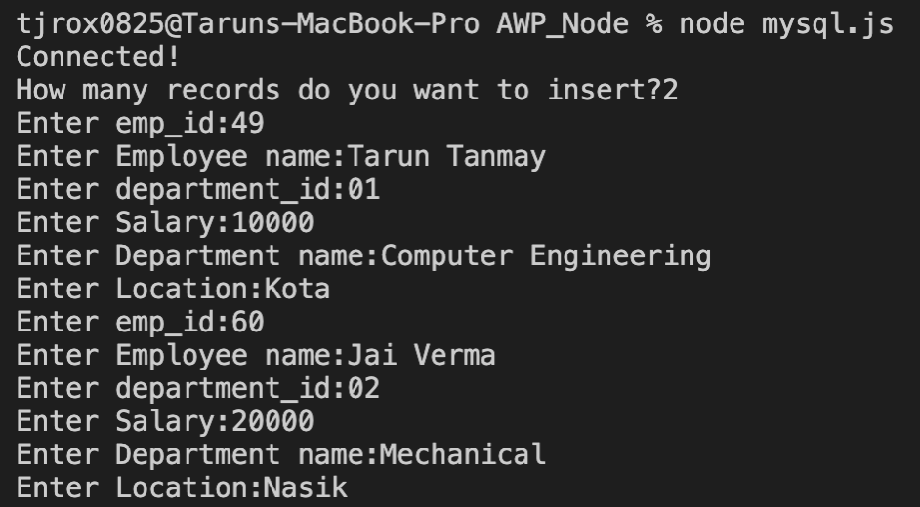

**Output:**

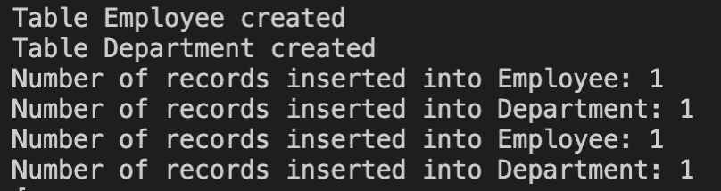

**Records Inserted:**

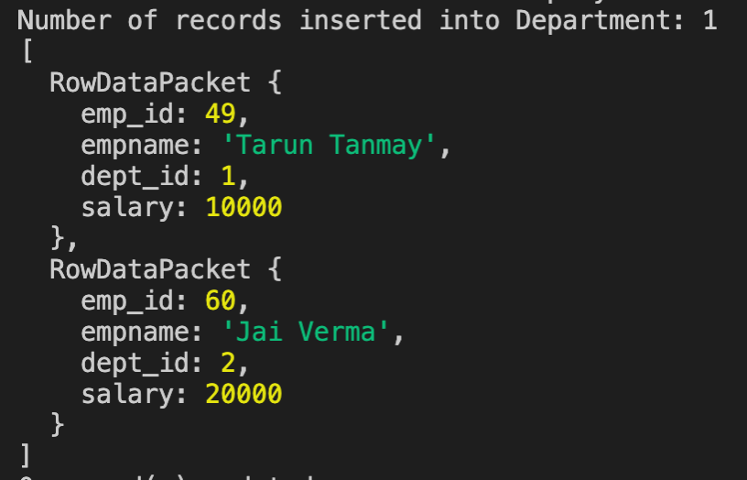

**Records Updated:**

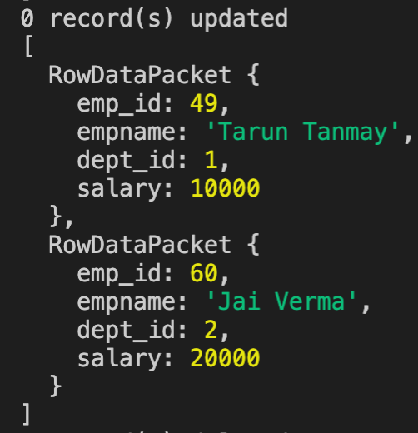

**Records Deleted:**

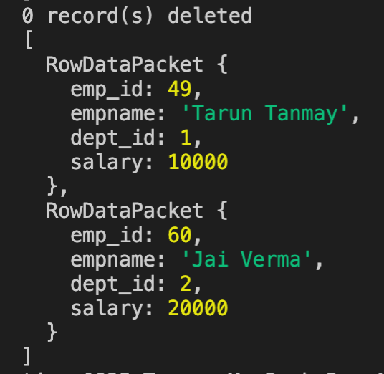

**B.2 Observations/Learning:**

Here, I’ve created an application using node js and MySQL which performs the CRUD operations such as creating Employee Table, updating and deleting the records of a database named ‘mydb3’.

**B.3 Conclusion:**

In this experiment, I’ve successfully implemented CRUD Operations with Node and MySQL

**Experiment 10**

**PART B**

(PART B: TO BE COMPLETED BY STUDENTS)

**(Students must submit the soft copy as per following segments within two hours of the practical. The soft copy must be uploaded on the Blackboard or emailed to the concerned lab in charge faculties at the end of the practical in case the there is no Black board access available)**

|  |  |
| --- | --- |
| Roll No.: N049 | Name: Tarun Tanmay |
| Program: MBATech CE | Division: B |
| Batch: B3 | Date of Experiment: |
| Date of Submission: | Grade: |

**B.1 Output:**

**Mongo2.js:**

var MongoClient = require('mongodb').MongoClient;

var url = "mongodb://localhost:27017/mydb";

//CRUD- CREATE, READ, UPDATE, DELETE

MongoClient.connect(url, function(err, db)

{

if (err) throw err;

console.log("Database created!");

var dbo = db.db("mydb");

var myobj = {name:"Tarun Tanmay", address:"Kota"};

//insert, insertOne,insertMany

dbo.collection("student").insertOne(myobj,function(err,res)

{

if (err) throw err;

console.log("Document 1 is inserted!");

});

var myobj = [{name: "Jai Verma", address: "Punjab", course: "ML"}, {name: "Sudhir Sharma", address: "Hyderabad", course: "AWP"}, {name: "Karan Garg", address: "Kota", course: "IOT"}, {name: "Aditya Mittal", address: "Shirpur", course: "Managemnet"}, {name:"Ishaan Raonka", address: "Kota", course:"Btech"}];

dbo.collection("student").insertMany(myobj, function(err,res)

{

if (err) throw err;

console.log("Document 2 inserted! ");

});

//this will retrieve the first document from collection*/

dbo.collection("student").findOne({}, function(err,result)

{

if(err) throw err; //result will have id,name, address

console.log(result);

});

//this will retrieve the name of the first studentdocument from collection

dbo.collection("student").findOne({}, function(err, result) {

if (err) throw err;

console.log(result.name);

});

//this will retrieve all the document from collection

dbo.collection("student").find({}, {projection:{ _id: 0, name: 1,address:1} }).toArray(function(err, result) {

if (err) throw err;

console.log(result);

});

//update employ set address="Kota" where name="Tarun Tanmay";

dbo.collection("student").updateMany({name:"Tarun Tanmay"},{$set:{address:"Kota"}},function(err, result){

if (err) throw err;

console.log(result.n + " document(s) updated");

});

//this will retrieve all the document from collection where student name is "Tarun Tanmay"

dbo.collection("student").find({}, {projection: { _id: 0, name: 1,address:1} }).toArray(function(err, result) {

if (err) throw err;

console.log(result);

});

dbo.collection("student").find({name:/^x/}, {projection: { _id: 0, name: 1,address:1} }).toArray(function(err, result) {

if (err) throw err;

console.log(result);

});

var mysort = { name:1};

dbo.collection("student").find().sort(mysort).toArray(function(err, result) {

if (err) throw err;

console.log(result);

});

var myquery = {address: /^d/};

dbo.collection("student").deleteMany(myquery, function(err, obj) {

if (err) throw err;

console.log(obj.result.n + " document(s) deleted");

});

});

**Output:**

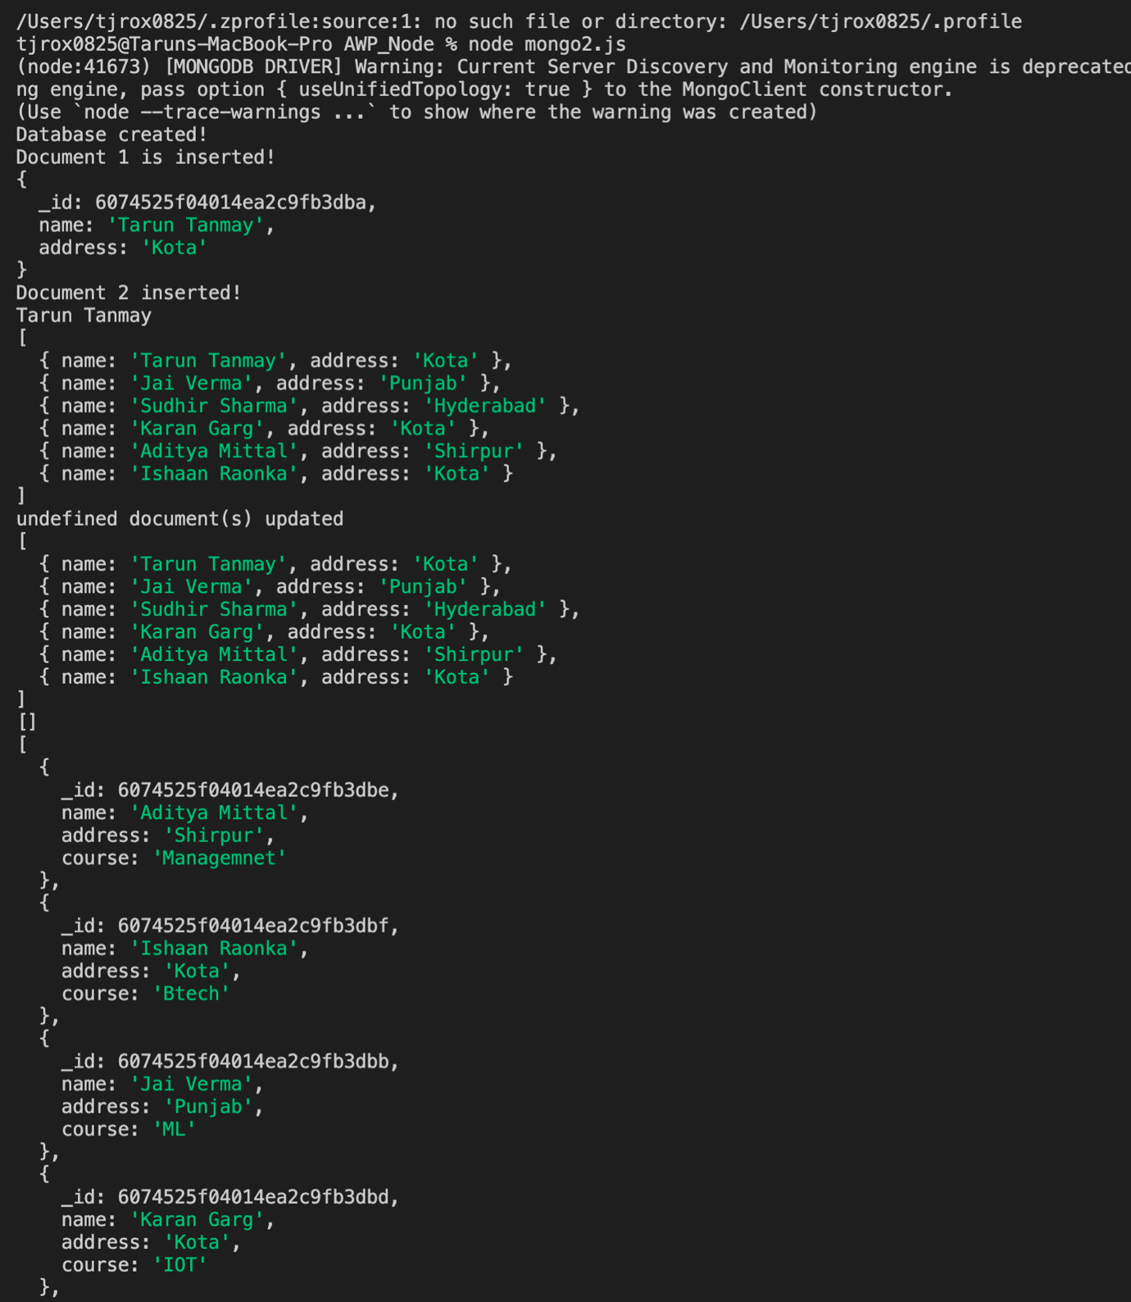

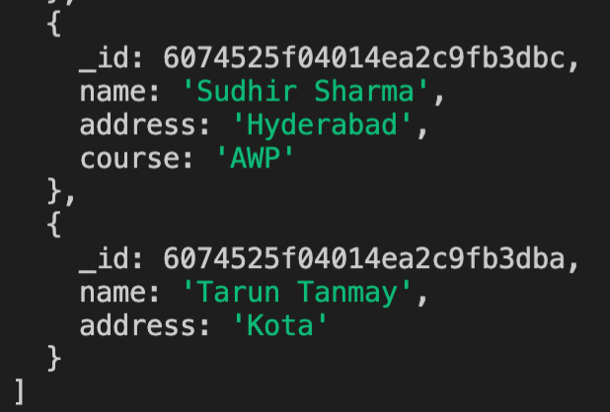

**MongoDb Compass:**

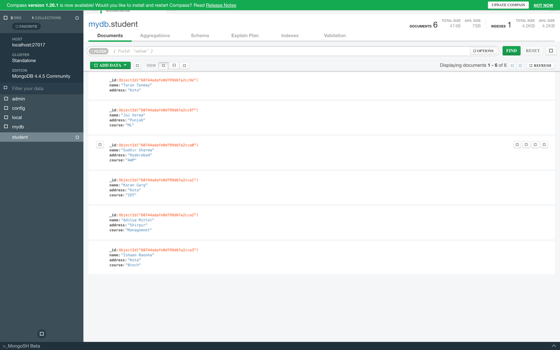

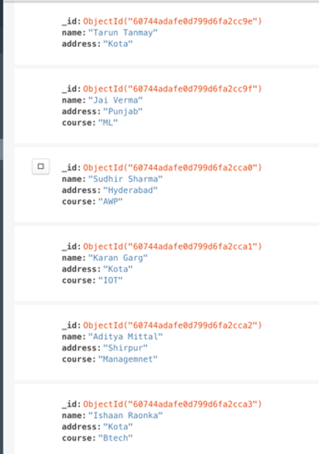

**B.2 Observations/Learning:**

I’ve created an application with NodeJS and MongoDb to implement CRUD functions like create, read, update, and delete.

**B.3 Conclusion:**

I’ve successfully implemented CRUD operations using MongoDb and NodeJS.